

**CS5551 – Advance Software Engineering Project**

**Application Name: “COURSE BUDDY “**

**TEAM NUMBER: 9 TEAM MEMBERS:**

**VAMSI KRISHNA CHALLA**

**SHANKAR PENTYALA**

**GIRISH KUMAR REDDY NAGELLA**

**Project Deployment & Project Management**

**Project Deployment:**

**User Manual:**

**Table of Contents:**

|  |
| --- |
|  |
| Introduction |
| Usage of system |
| error recognition and handling |
| sample interaction |
| known bugs and deficiencies |
|  |

**INTRODUCTION:**

**COURSE BUDDY**

Course buddy is an interactive application which acts as lifeline between students and the teaching fraternity. Student fraternity has a tendency to work along deadlines and many of the times, they tend to forget the deadlines and lose marks even having competency to complete on time. Not only deadlines, many of the student fraternity has a feeling of introvert of not being able to directly interact with the teaching fraternity.

Our COURSE BUDDY application tries to lessen the gap between teaching and student streams and also provide an interface for free flow of communication. Giving it a social media touch, would easily attract the students to make use of it.

Many times we face difficulty in finding out means to talk to our teaching faculty because of lack of availability of information. Myself, I am example how a student face difficulty in reaching faculty to break many barriers regarding the subject. As an international student, I was very much astonished at the etiquette of the college and I pulled myself backward from making a step ahead to clear my doubts regarding subjects. In the initial days, I was not able to find means of communication to reach out the faculty to be able to clarify my doubts regarding the subject and course curriculum.

So goes a saying, “Failure is the stepping stone of success.” As a blind follower of that, we tried to utilize this project opportunity to build an interface that would address the problems faced by us.

**Usage of system:**

This application is intended to be used only by the students of UMKC and so is limited only to the students, TAs and Professors of UMKC.

Users apart from those mentioned above can’t use this application.

Users should have a Mobile with Android platform (Lollipop or Newer) to use this application. Users may need their SSO’s to have access to this application.

A good internet connection is needed to use this application and 4G connectivity is optimal for some features in this application.

Users need to grant the permissions to app in order to make use of all the features of the app.

**Error Recognition and Handling:**

In case of Situations where even after successful login, you may not have access to app. In this case,

you may need to verify your email by clicking on the email verification link sent to you. Only upon successful email verification, users will have access to this application.

In case of app crash,

please make sure that you granted all the permissions app requested for.

In some situations, app may not perform all its functions at optimal speed due to poor or No internet connectivity. So, make sure that you are connected to internet while using this application.

**Sample interaction:**

**Home page for application:**

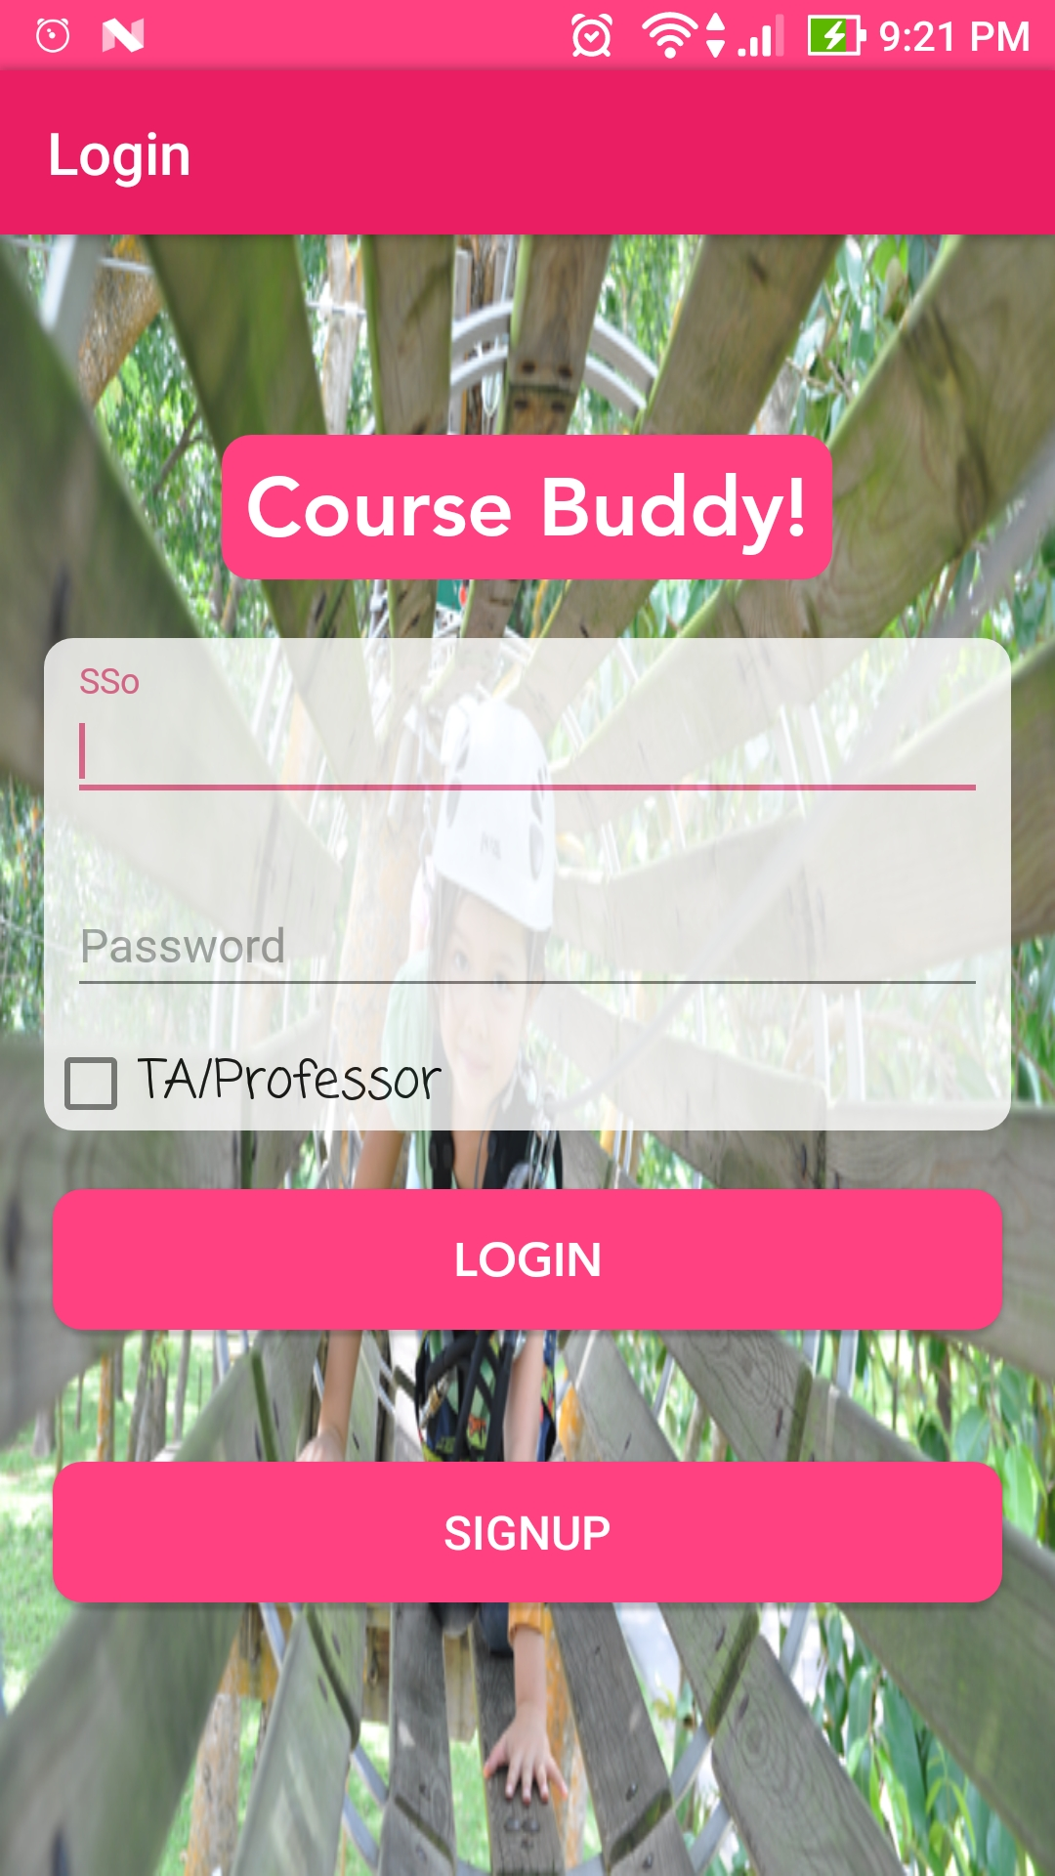

**On successful login, we would get the option to choose the course:**

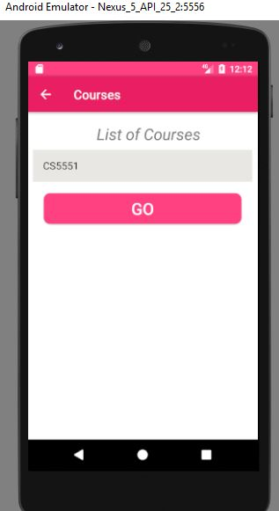

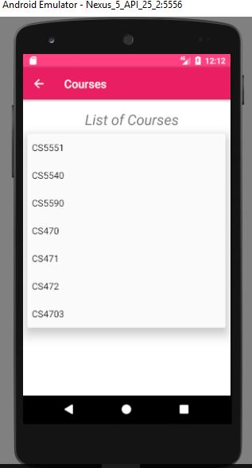

**On selecting the course, we would get an option to talk with anyone:** 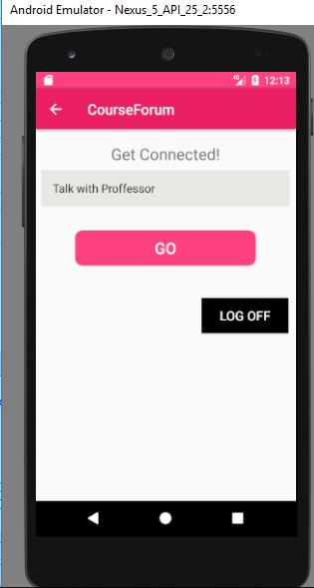

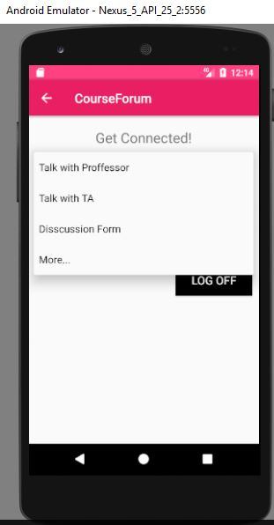

**On selecting the option Discussion Forum, A chat Screen opens.**

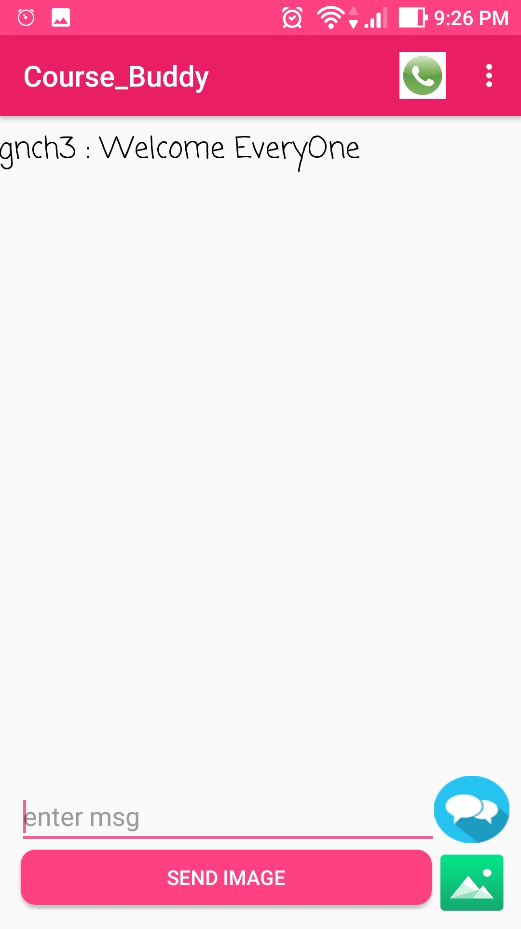

**On selecting the option Talk with TA, another screen opens**

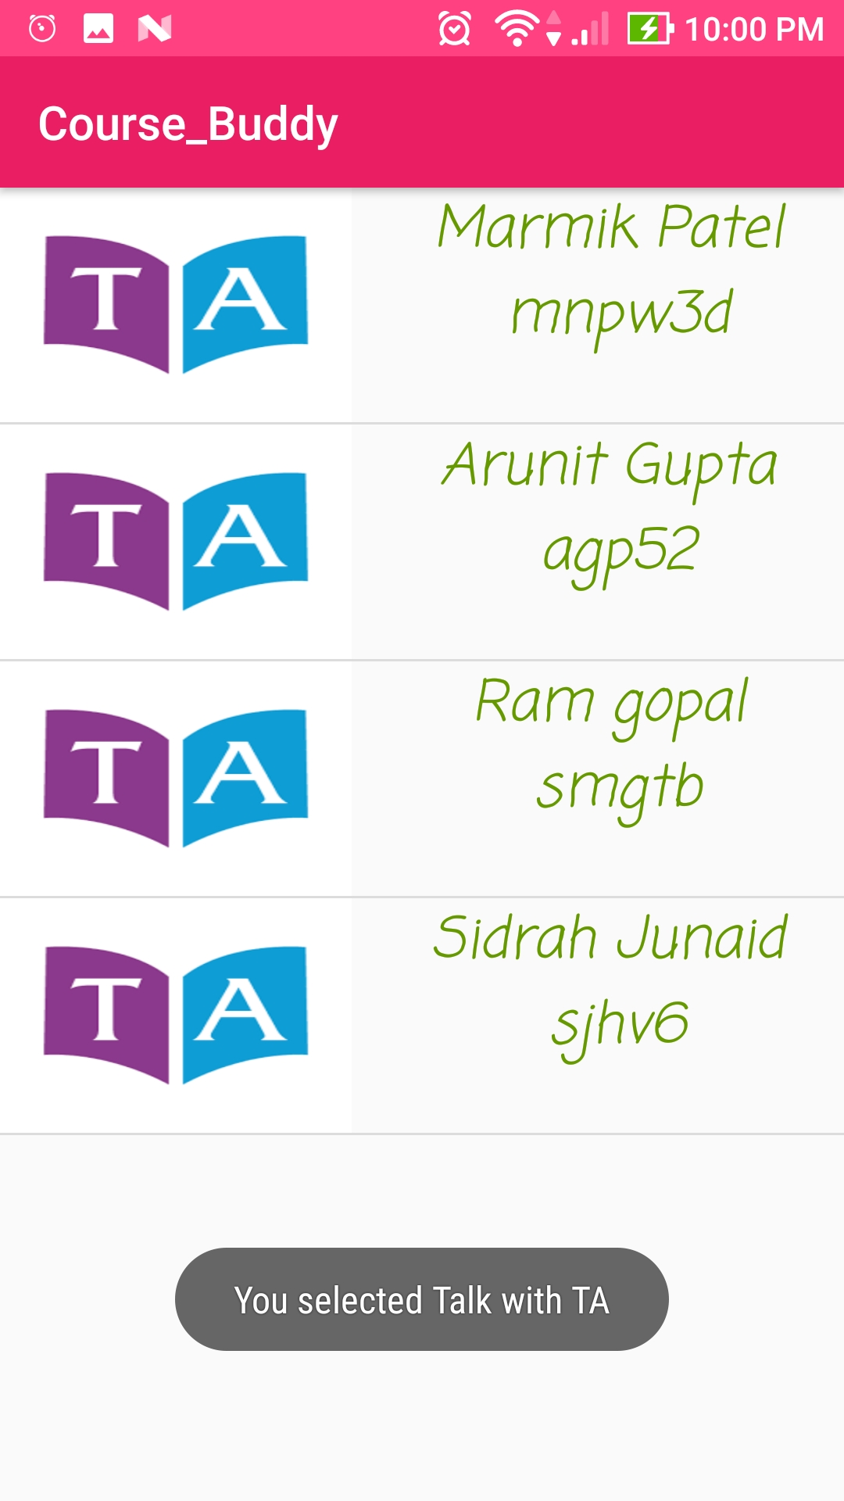

**On selecting the option Talk with professor, professor screen opens**

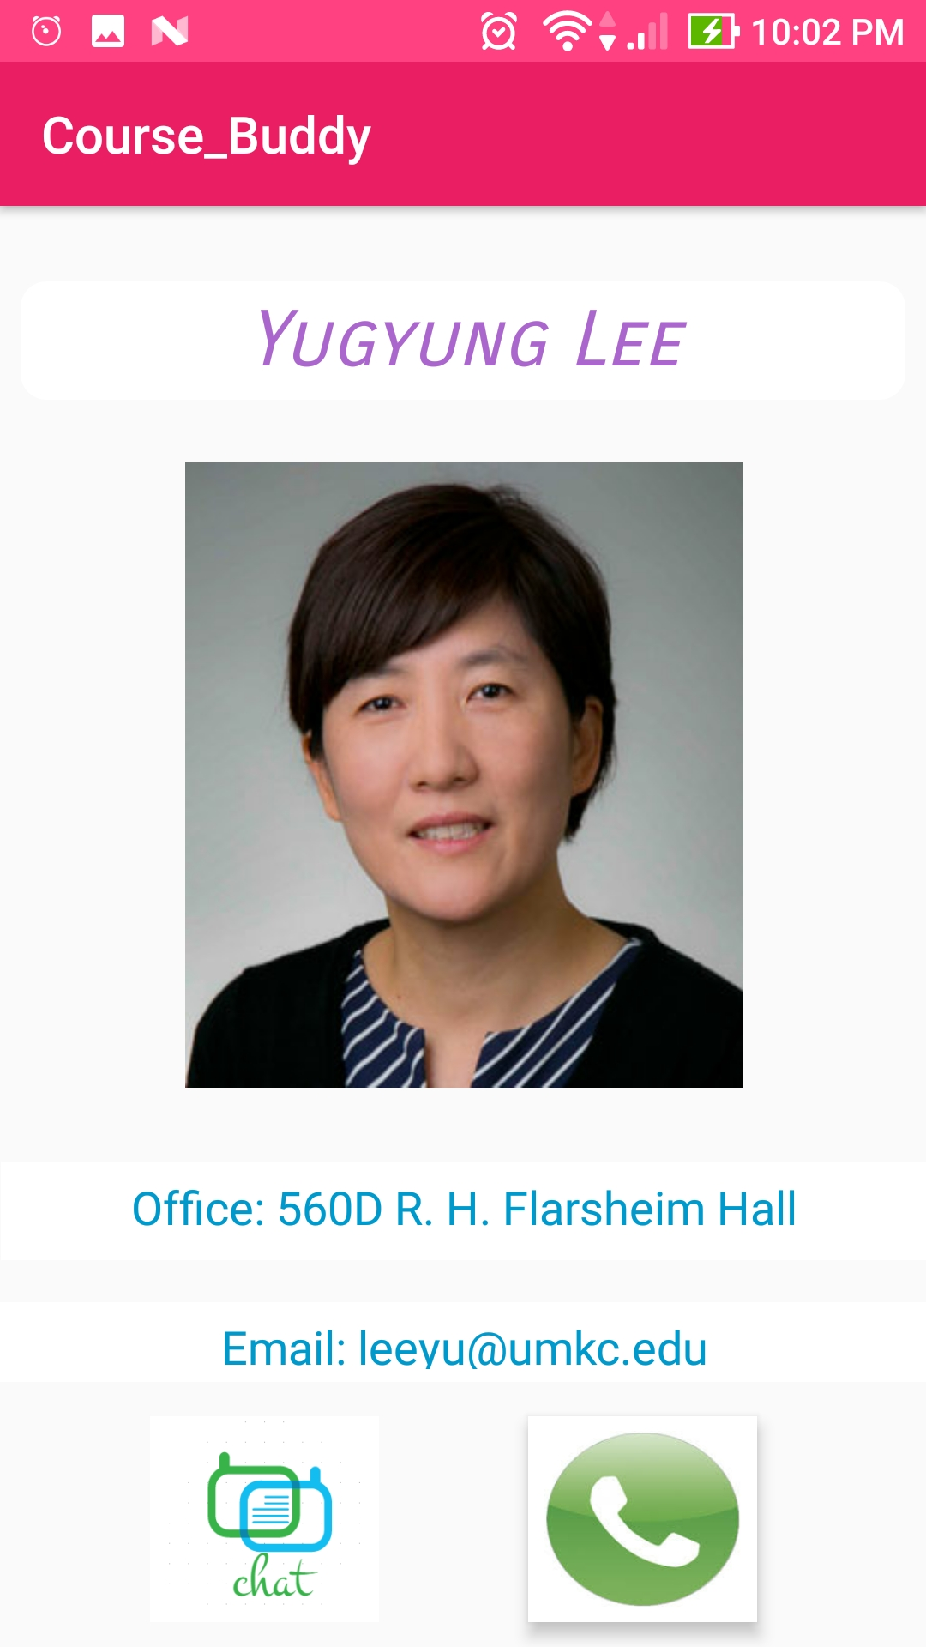

**Also, we can perform App-App Image Sharing:**

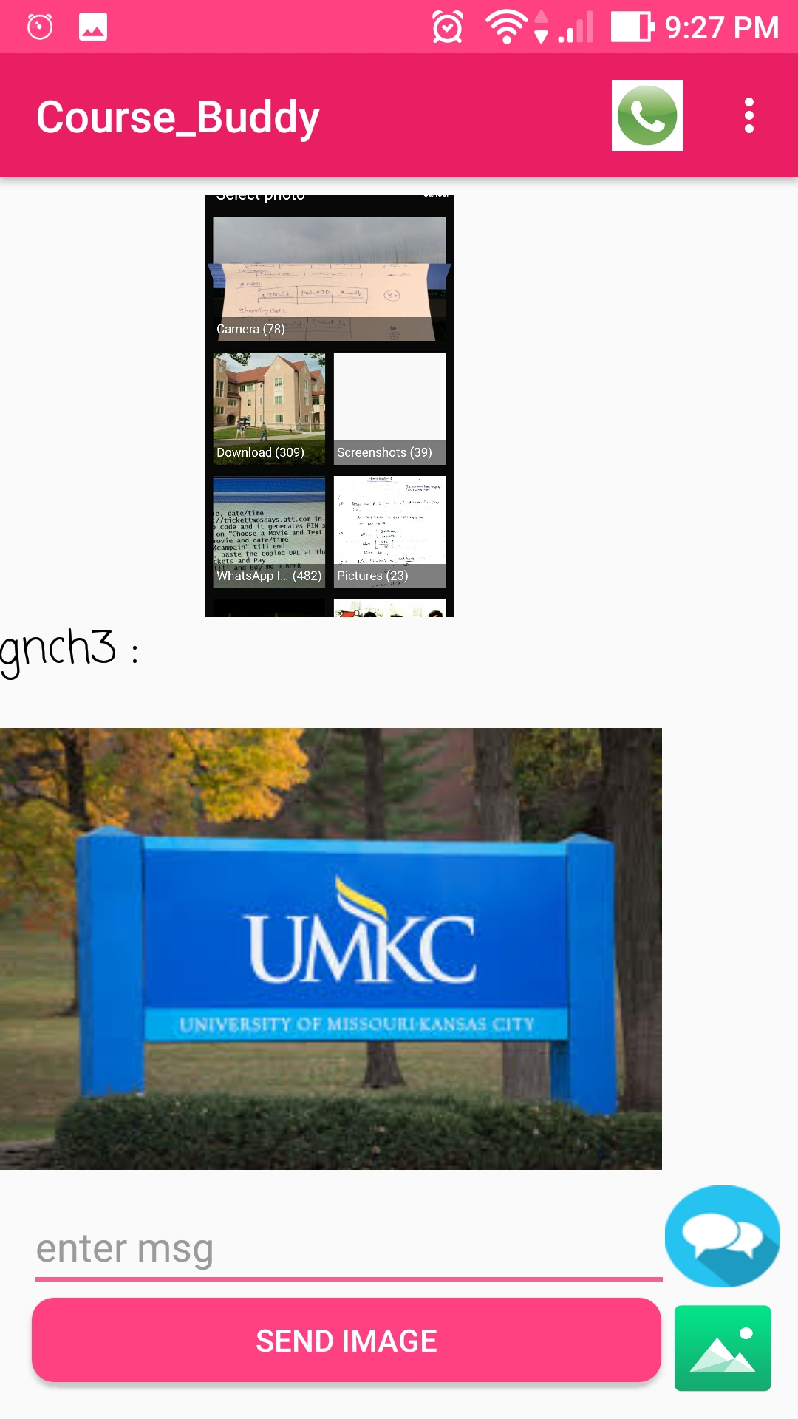

**Finally, App-App calling is possible,**

**If we login as Tutor/TA:**

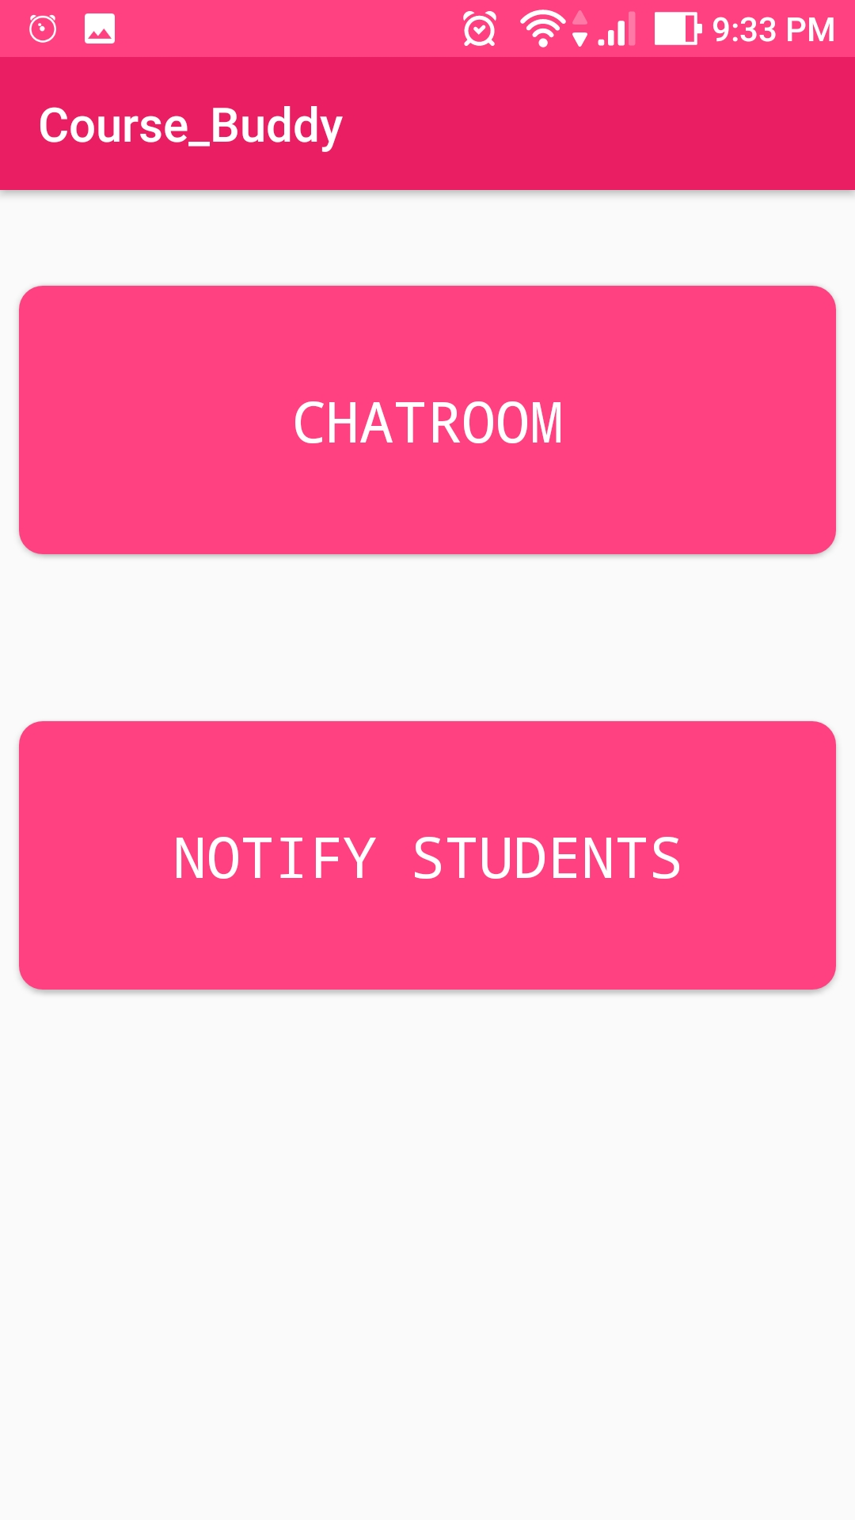

**Tutor/TA can send Important updates to students**,

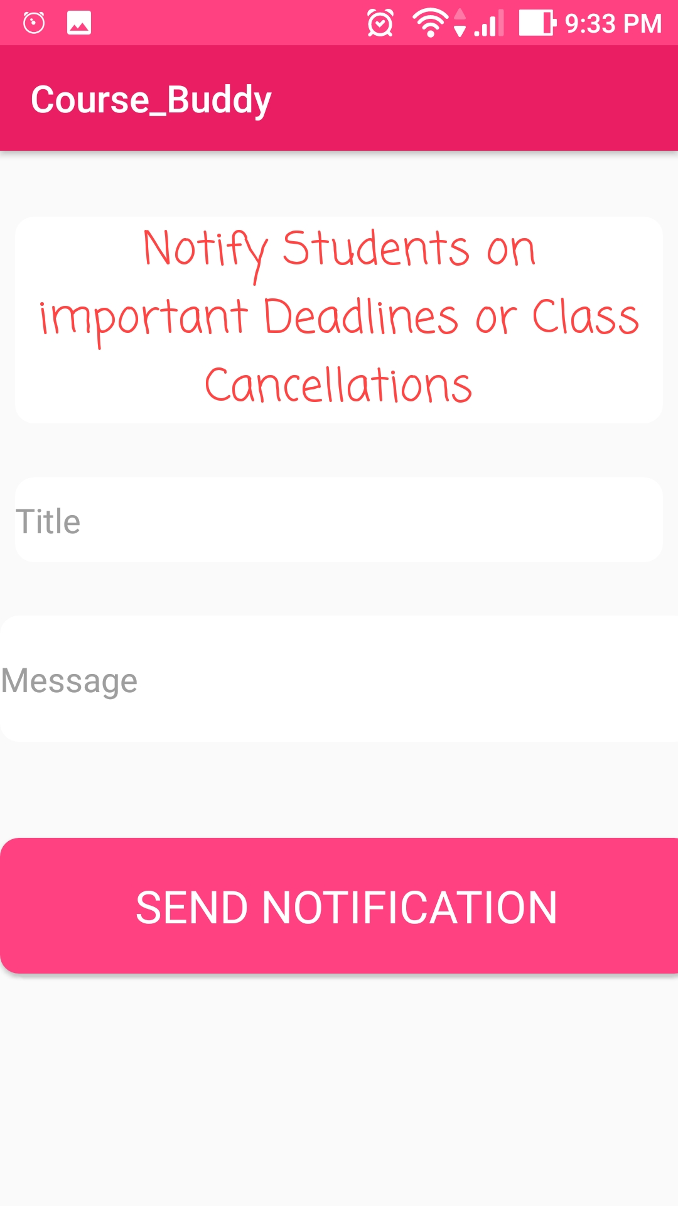

**Known Issues and Deficiencies:**

There are very few Deficiencies in this app, they are:

Application doesn’t work offline, it needs internet connectivity for every functionality.

Application is limited to students of UMKC only.

**Project Management:**

**Project management report:**

We used Agile Process for the development of our project. So, we developed our project in four Increments. In each increment, we set the objectives for next increment and met the main objective of our application completely by the end of our final increment.

In each increment,

We added specific features to the application and finally integrated all those features in our final increment and we had faced many issues in each increment and resolved them by assigning them to each team member.

We used GitHub in order to maintain our project code and used Zen Hub along with GitHub for better project management among team members.

We set Milestones for each Increment and met our deadlines by implementing all the goals set for that increment. We used branches in GitHub and used Pull Requests to Confirm Merging branches to Master Branch after Committing to secondary branches.

**Project planning:**

We developed our project completely in four increments.

We assigned Milestones for each increment and we successfully met all the goals in each increment by our deadlines and we resolved the issues occurred in each increment by working together and making use of Boards in Zen Hub.

We tracked our progress by making use of Burndown charts in GitHub for each Milestone.

We also made use of Velocity Tracking feature of GitHub and analyzed the work flow in different Increments by using Velocity Tracking for all Milestones.

**Project plan for Increments is shown below:**

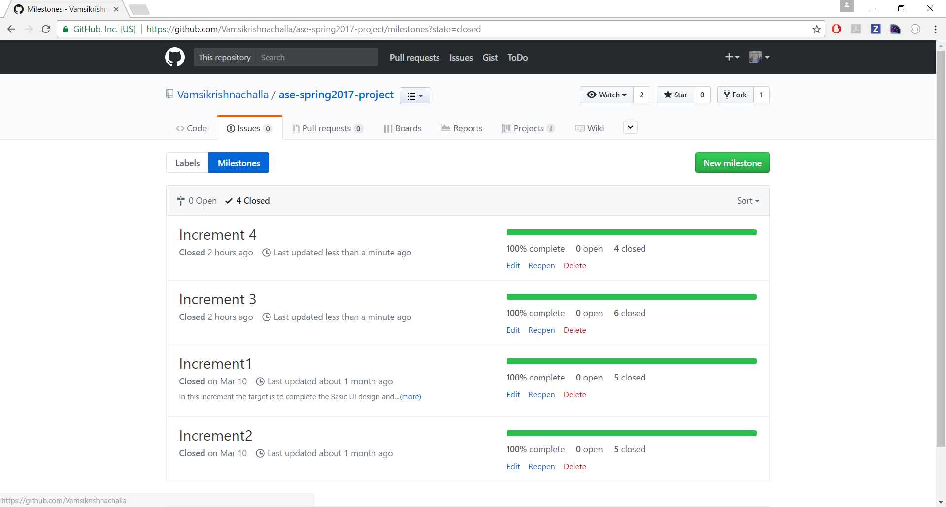

**Issues encountered and resolved are shown below**:

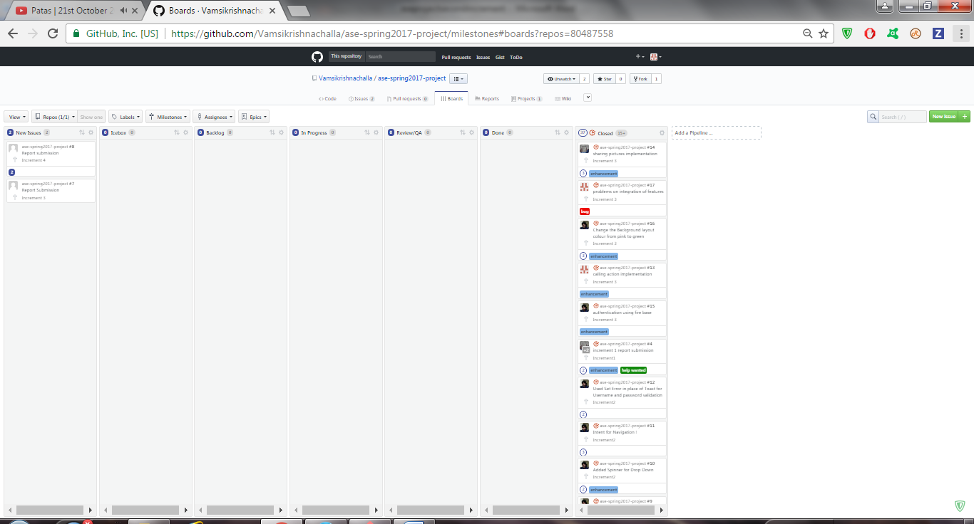

**Velocity Tracking:**

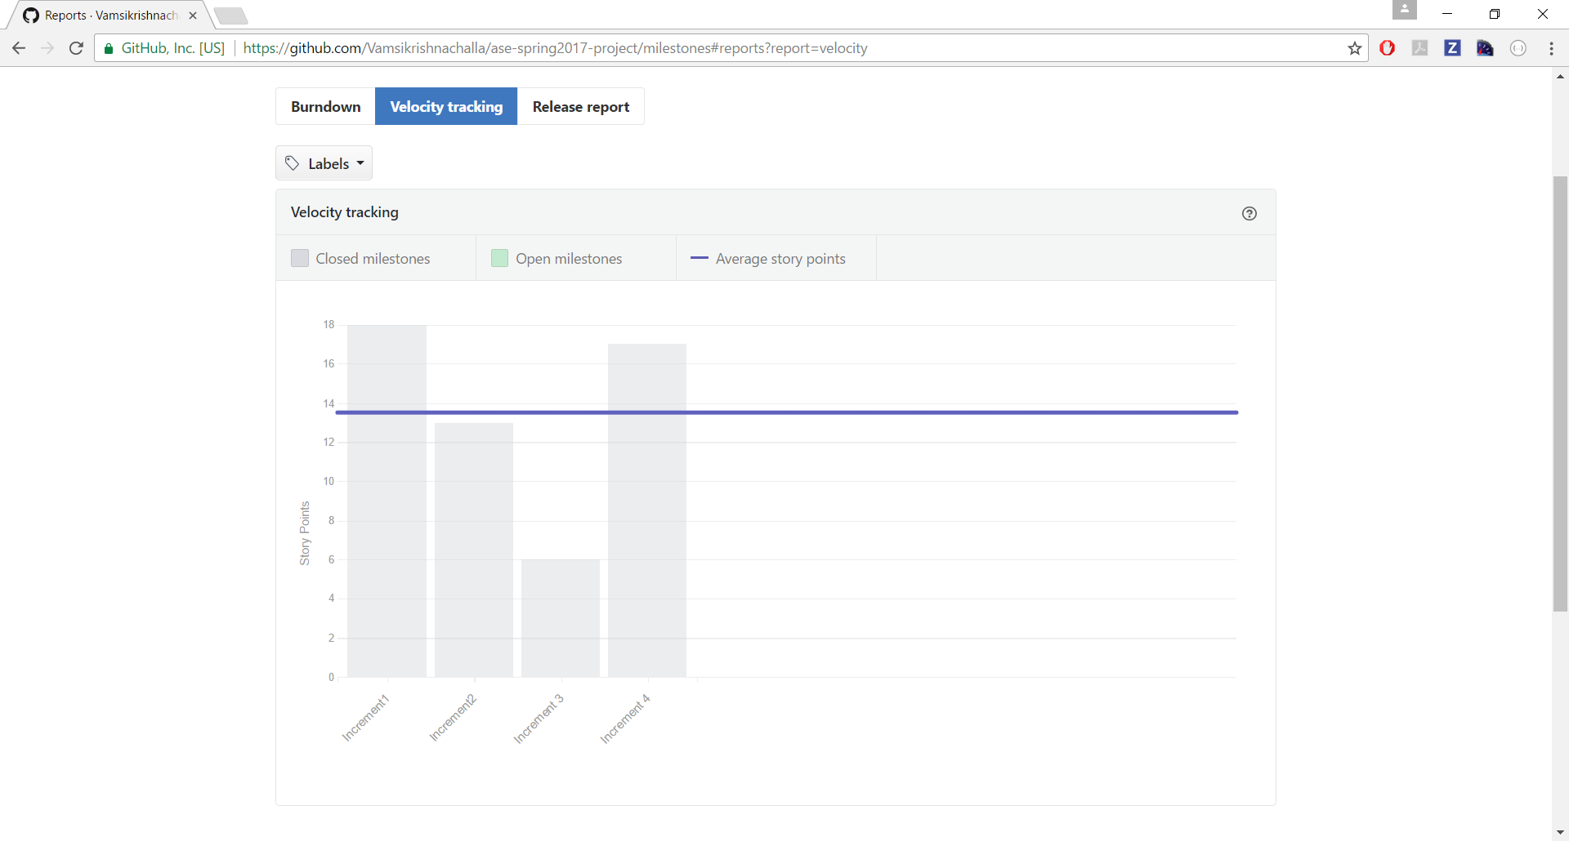**Final project evaluation:** Our project mainly aims at providing a interface bridge between course buddies, teaching assistants and professors related to a particular subject. Our project with the features of messaging and calling to professor, teaching assistants and our course buddies would quench the thirst of our primary goal to break the barriers of communications between all people. While developing the project, we have faced many issues in developing various modules in our project. Agile process, very much helped us to overcome these hurdles and build an result oriented application. At various increments, we were able to evaluate our project ourselves and reach the destiny to get the required output. Sticking to the project plan schedule is the key point of success in the project development at various phases. Not skipping any deadlines have become a key point in the project management at various phases of development. Firstly, we divided the project into three modules among ourselves, and we started to develop the modules individually. Later at various increment deadlines, we started to integrate the modules and test it for operability. As we have good coordination, we did not face any team management issues in the project development journey. We did not look up at this project at no level down than a real world one. We have worked with same zeal and passion with which we would have worked for a real world one. If it was a real world one, we would have access more resources due to budget availability and it would help us to enhance security and data base management features more effectively.



**CS5551 – Advance Software Engineering Project**

**Application Name: “COURSE BUDDY “**

**PROJECT INCREMENT -1 REPORT**

**TEAM NUMBER: 9 TEAM MEMBERS:**

**VAMSI KRISHNA CHALLA**

**SHANKAR PENTYALA**

**GIRISH KUMAR REDDY NAGELLA**

**INTRODUCTION:**

**COURSE BUDDY**

Course buddy is an interactive application which acts as lifeline between students and the teaching fraternity. Student fraternity has a tendency to work along deadlines and many of the times, they tend to forget the deadlines and lose marks even having competency to complete on time. Not only deadlines, many of the student fraternity has a feeling of introvert of not being able to directly interact with the teaching fraternity.

Our COURSE BUDDY application tries to lessen the gap between teaching and student streams and also provide an interface for free flow of communication. Giving it a social media touch, would easily attract the students to make use of it.

Many times we face difficulty in finding out means to talk to our teaching faculty because of lack of availability of information. Myself, I am example how a student face difficulty in reaching faculty to break many barriers regarding the subject. As an international student, I was very much astonished at the etiquette of the college and I pulled myself backward from making a step ahead to clear my doubts regarding subjects. In the initial days, I was not able to find means of communication to reach out the faculty to be able to clarify my doubts regarding the subject and course curriculum.

So goes a saying, “Failure is the stepping stone of success.” As a blind follower of that, we tried to utilize this project opportunity to build an interface that would address the problems faced by us.

**Project Goal and Objectives:**

**Overall goal:**

Our primary goal is to develop a hybrid application “COURSE BUDDY” which is an interface between students and faculty. This interface is made using android software development kit and various other services which are needed for smooth running of applications.

**Specific objectives:**

Course buddy is used purely for educational purpose. Students login into the application to be able to talk with tutors, teaching assistants and also their course buddies without compromising their privacy

**Specific Features:**

Not compromising student’s privacy:

Many doubts of students can actually be solved by talking with their friends. But in an international institution we may not be able to easily mingle with students. Our course buddy would create a discussion forum without disclosing student’s identity and it would facilitate the student to clarify their doubts easily.

Talk with tutors and teaching assistants on a single platform:

Instead of using mail based communication to reach out to professors and using mail based or spreadsheet based communication to reach out to teaching assistants, this interface provides a unique platform to reach out both of them at a single click.

**Significance:**

This application in creating an healthy environment where learning evolves from different aspiring minds and would help each other to excel themselves by taking help of their professors, teaching assistants and their friends.

**Project Plan:**

**Schedule for different Increments:**

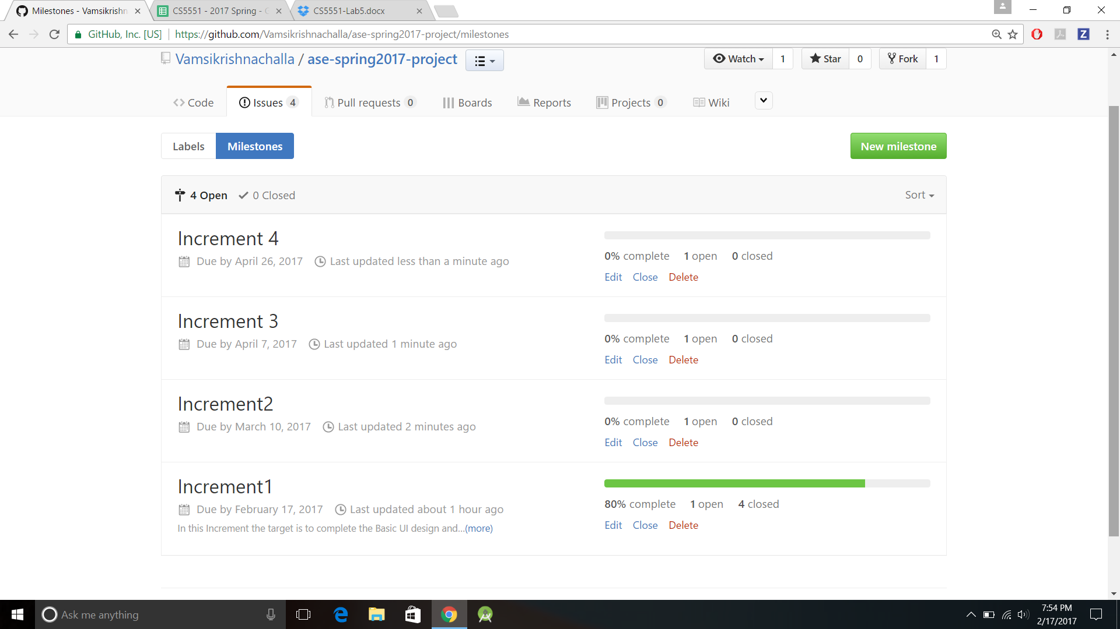

**Project timelines, Members and responsibilities:**

Below are the issues that were created under each increment.

These tasks are assigned to team members.

Once the respective task is accomplished, the issue is moved to closed state.

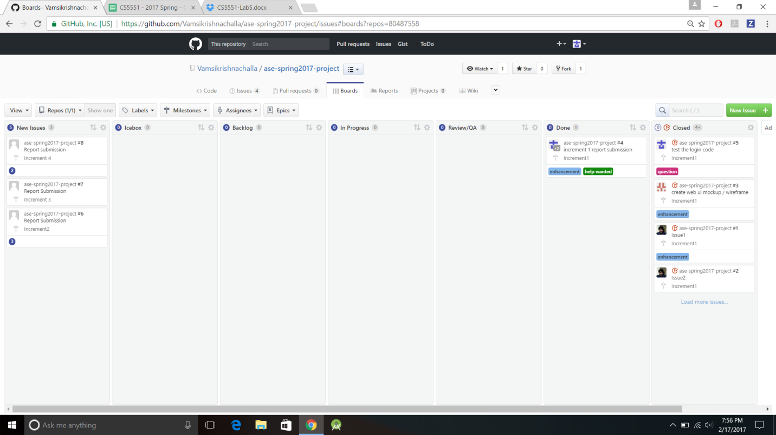

**Burndown chart:**

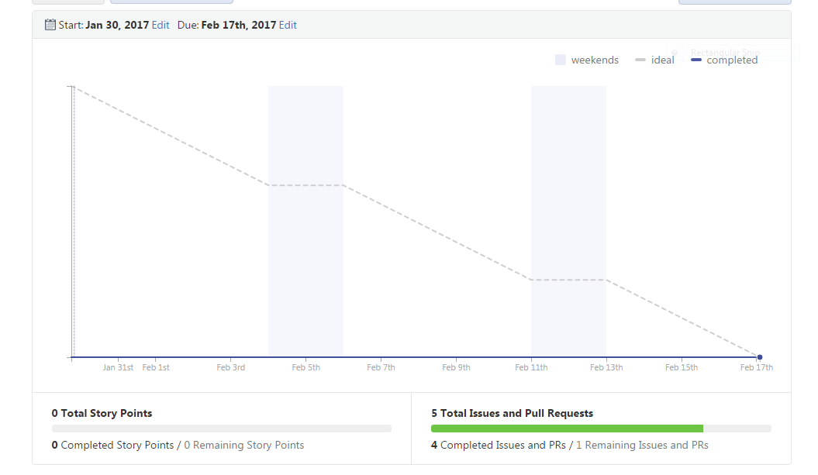

**4. First Increment Report:**

In this increment we have designed UI mockups by designing wireframes and by keeping them in mind, we have designed login pages, course selection page and choosing the option to talk with anyone of the professors or teaching assistants or course buddies.

**4.1. Existing services / REST API:**

In this current increment we have not used any of the api’s. In the future increments if we need any of them for enhancement of our app , we’ll email and chat api’s.

**4.2. Detail design of features:**

**4.2.1 Wireframes:**

**The wireframes for first phase of project are shown below:**

**Login page: after user opens the application, one would be asked to enter the credentials to enter into the application.**

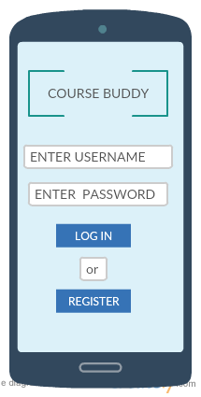

The user should have already be registered i.e., the details of the user must be already available with us as it is related to university and the details of student would be uploaded on a pre hand for authentication.

This wireframe comes once the login is successful.

In this wireframe we will be able to see the options to choose the courses In which we have enrolled.

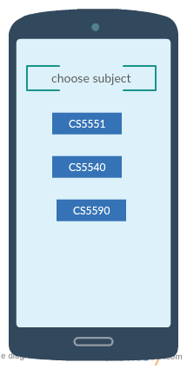

Upon selecting the subject, we would get the option to talk with one of the required persons which we are needed to talk to like:

Professor

Teaching assistants

Course buddies.

This is the wireframe for choosing the option to talk or else log off from the application.

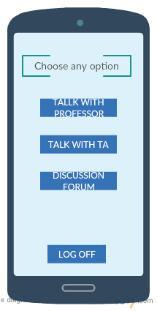

**4.2.2 User Stories:**

**Class diagram:**

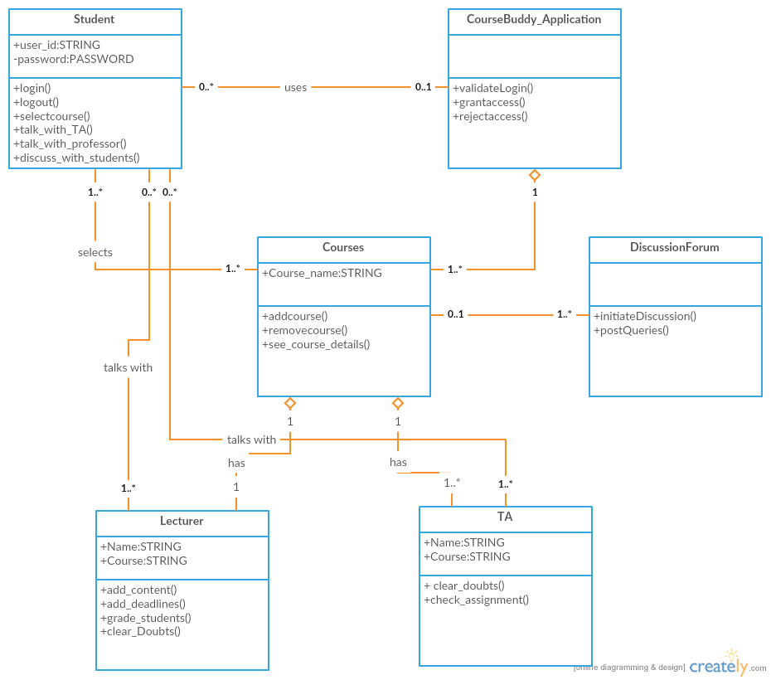

**Software architecture diagram:**

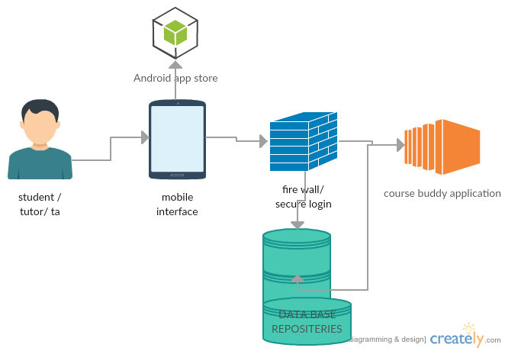

**Sequence diagram:**

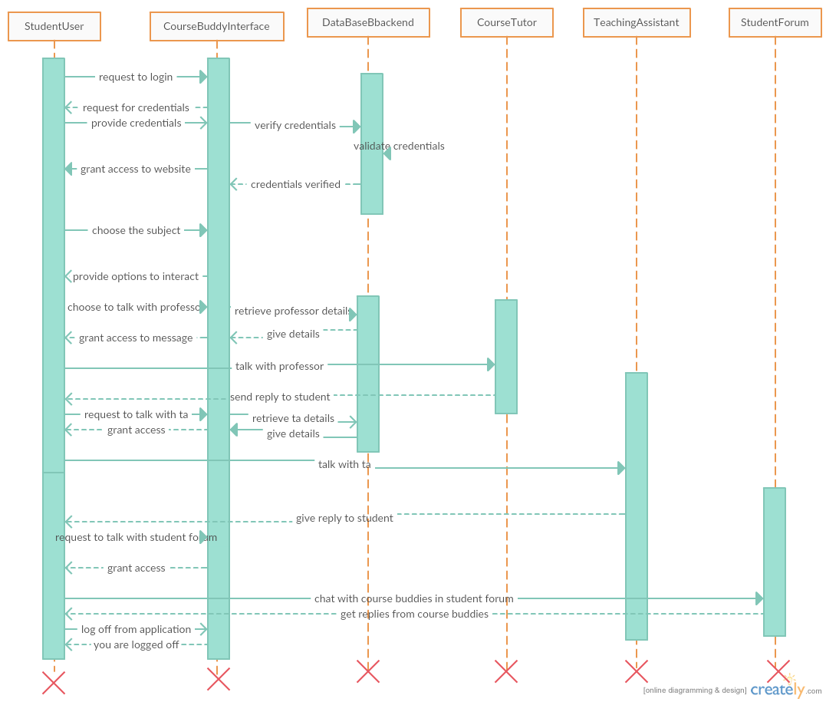

**4.3. Implementation:**

**Home page for application:**

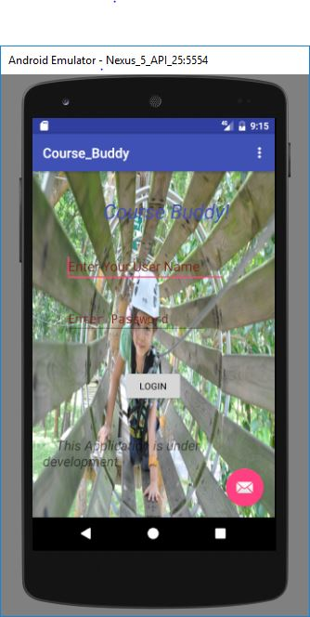

**On successful login, we would get the option to choose the course:**

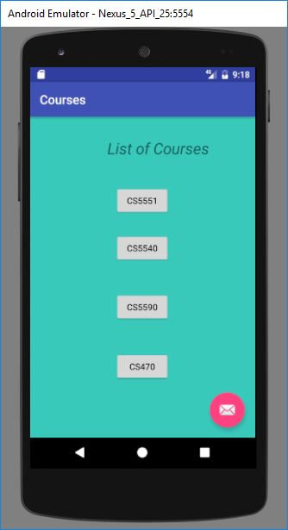

**On selecting the course we would get an option to talk with anyone:**

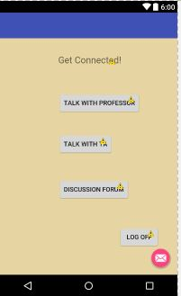

**4.4. Unit Testing:**

The below are the unit cases for first phase of the project:

|  |  |  |  |  |
| --- | --- | --- | --- | --- |
| s.no | Test case title | Description | Expected outcome | result |
| 1 | User login verification | The user should provide valid email id and password to login. | Upon successful login, user needs to be moved to home page | pass |
| 2 | User login validation with invalid credentials | User will enter wrong credentials | As the user have entered wrong credentials, access should be declined. | pass |
| 3 | User login verification without details | User will not enter any credentials. | User should not be granted access as he had not entered any credentials. | pass |
| 4. | Correct navigation to choosen page | User will give login credentials | Upon successful login, the page should navigate to course selection page | pass |
| 5 | Navigation after choosing the course | User will select the course he is enrolled in | Upon choosing the course, user needs to be navigated to talk with tutor, ta and discussion forum page | pass |

**4.5. Deployment:**

We have deployed our application on avd emulator and have taken screenshots.

We have explained about implementation in detailed in the above sections.

GitHub link for source code and documentation :

**4.6. Project Management:**

**Technologies used: Android SDK, JAVA SDK.**

**Software used: Android studio.**

**In this increment we have completed the following work:**

UML DIAGRAMS

Created increments in ZenHub

Created wireframes using creately

Login and registration form for android application

**Contributions:**

**Vamsi Krishna Challa: 33.33%**

**Shankar Pentyala: 33.3%**

**Girish Kumar Reddy Nagella: 33.3%**

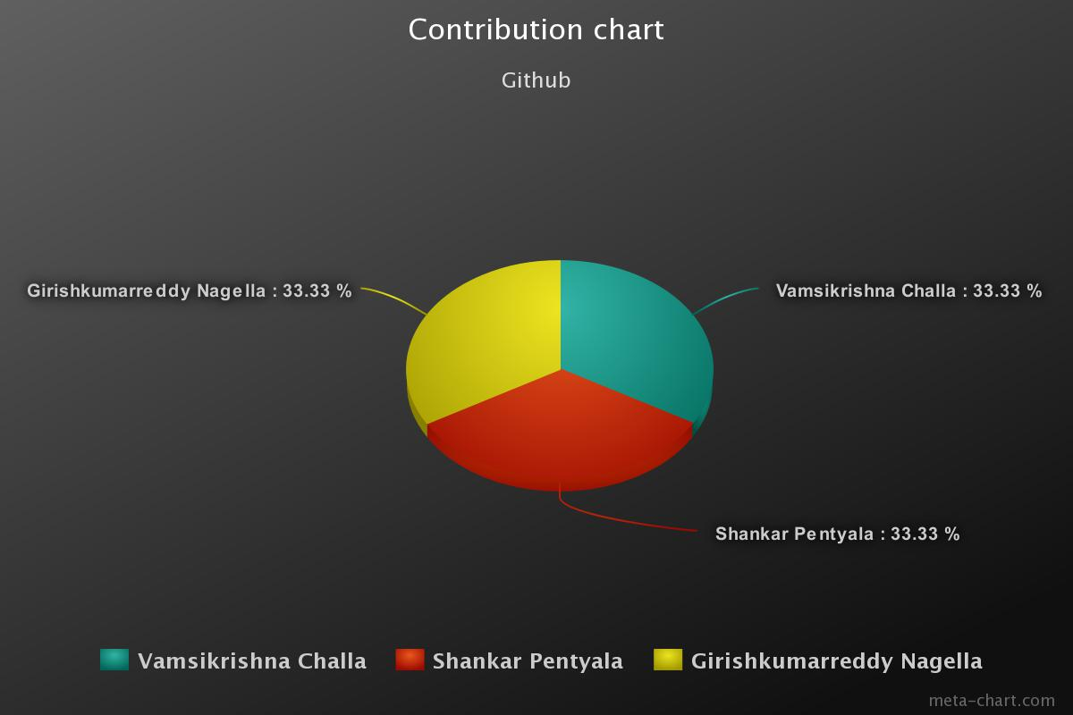

**PROJECT INCREMENT -2 REPORT**



**CS5551 – Advance Software Engineering Project**

**Application Name: “COURSE BUDDY “**

**TEAM NUMBER: 9**

**TEAM MEMBERS:**

**VAMSI KRISHNA CHALLA**

**SHANKAR PENTYALA**

**GIRISH KUMAR REDDY NAGELLA**

**INTRODUCTION:**

**COURSE BUDDY**

Course buddy is an interactive application which acts as lifeline between students and the teaching fraternity. Student fraternity has a tendency to work along deadlines and many of the times, they tend to forget the deadlines and lose marks even having competency to complete on time. Not only deadlines, many of the student fraternity has a feeling of introvert of not being able to directly interact with the teaching fraternity.

Our COURSE BUDDY application tries to lessen the gap between teaching and student streams and also provide an interface for free flow of communication. Giving it a social media touch, would easily attract the students to make use of it.

Many times we face difficulty in finding out means to talk to our teaching faculty because of lack of availability of information. Myself, I am example how a student face difficulty in reaching faculty to break many barriers regarding the subject. As an international student, I was very much astonished at the etiquette of the college and I pulled myself backward from making a step ahead to clear my doubts regarding subjects. In the initial days, I was not able to find means of communication to reach out the faculty to be able to clarify my doubts regarding the subject and course curriculum.

So goes a saying, “Failure is the stepping stone of success.” As a blind follower of that, we tried to utilize this project opportunity to build an interface that would address the problems faced by us.

**Project Goal and Objectives:**

**Overall goal:**

Our primary goal is to develop a hybrid application “COURSE BUDDY” which is an interface between students and faculty. This interface is made using android software development kit and various other services which are needed for smooth running of applications.

**Specific objectives:**

Course buddy is used purely for educational purpose. Students login into the application to be able to talk with tutors, teaching assistants and also their course buddies without compromising their privacy

**Specific Features:**

Not compromising student’s privacy:

Many doubts of students can actually be solved by talking with their friends. But in an international institution we may not be able to easily mingle with students. Our course buddy would create a discussion forum without disclosing student’s identity and it would facilitate the student to clarify their doubts easily.

Talk with tutors and teaching assistants on a single platform:

Instead of using mail based communication to reach out to professors and using mail based or spreadsheet based communication to reach out to teaching assistants, this interface provides a unique platform to reach out both at a single click.

**Significance:**

This application in creating a healthy environment where learning evolves from different aspiring minds and would help each other to excel themselves by taking help of their professors, teaching assistants and their friends.

**Project Plan:**

**Schedule for different Increments:**

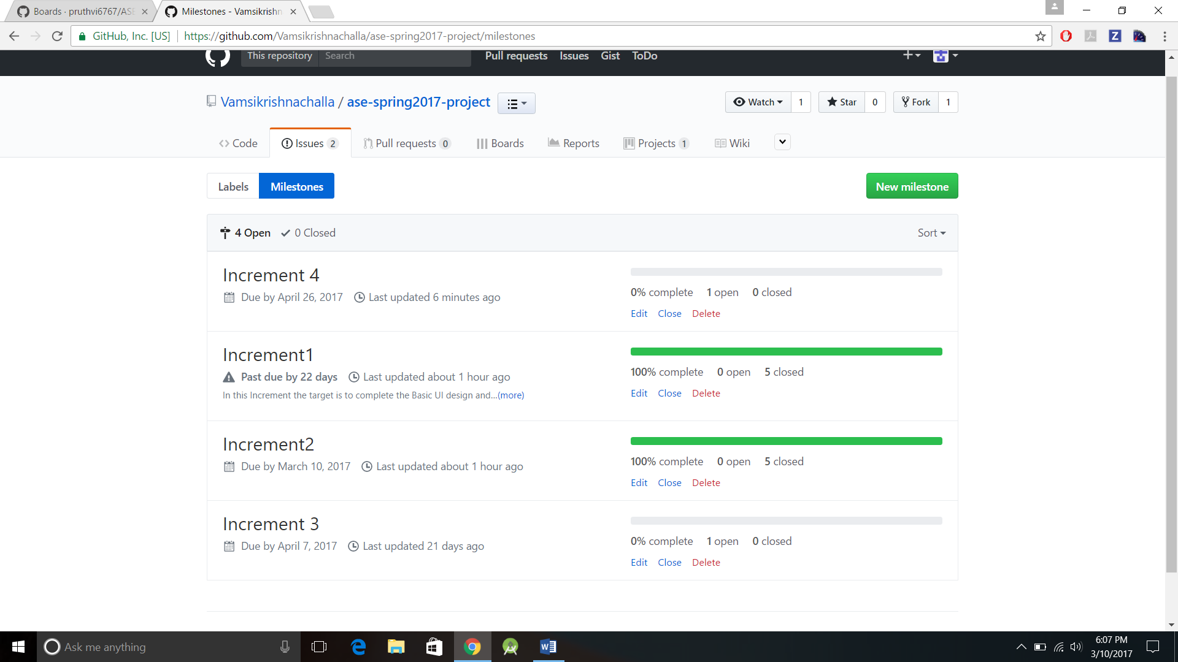

**Project timelines, Members and responsibilities:**

Below are the issues that were created under each increment.

These tasks are assigned to team members.

Once the respective task is accomplished, the issue is moved to closed state.

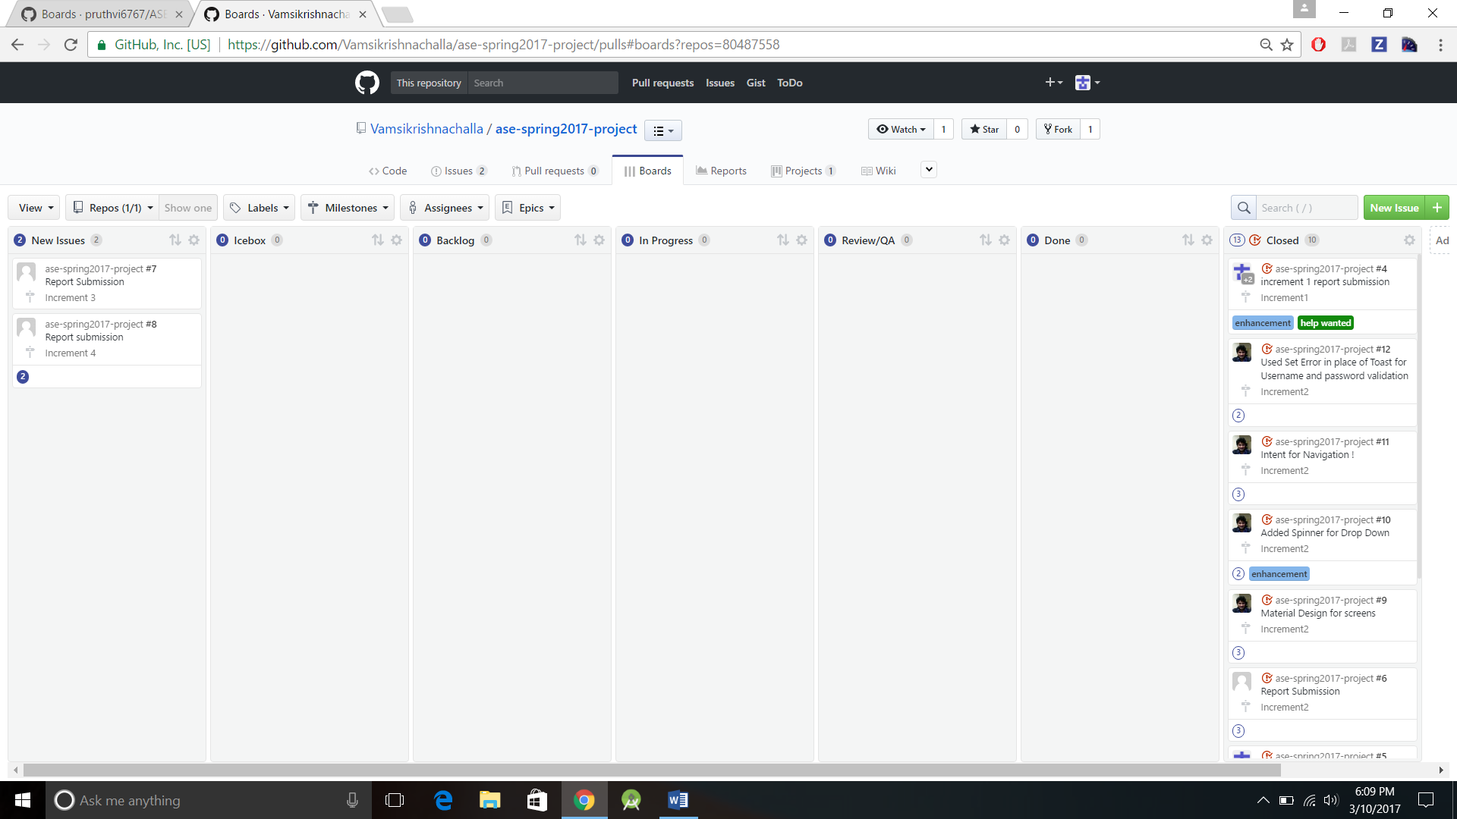

**Burndown chart:**

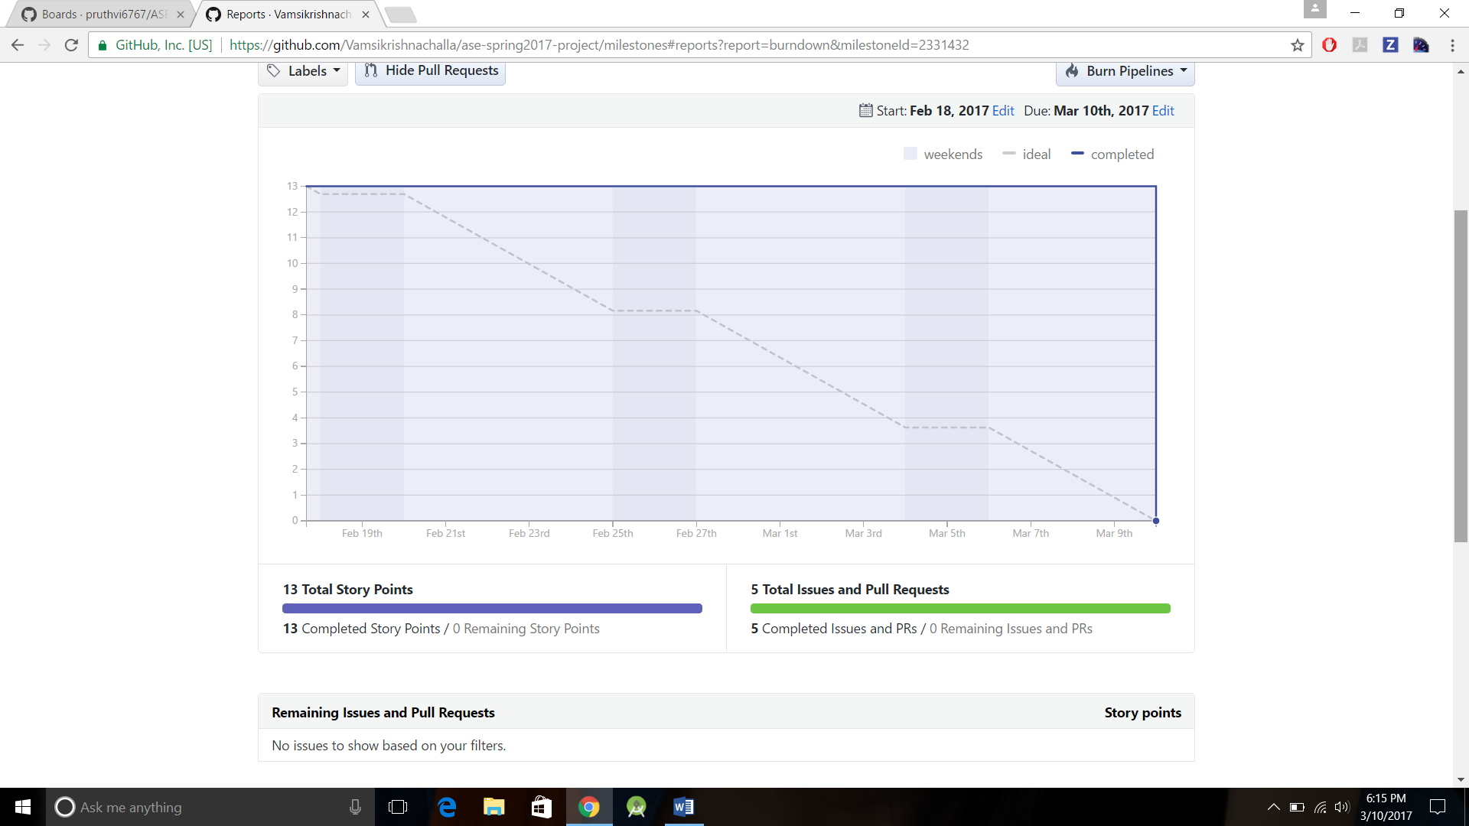

**3.4 Velocity Tracking:**

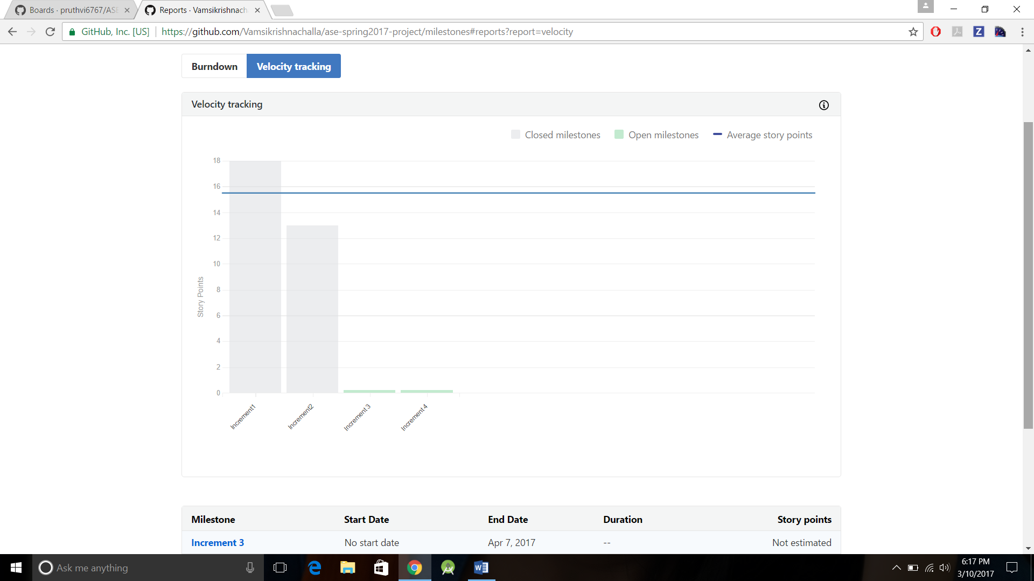

**4. Second Increment Report:**

In this increment we have designed UI mockups by designing wireframes and by keeping them in mind, we have designed login pages, course selection page and choosing the option to talk with anyone of the professors or teaching assistants or course buddies.

**4.1. Existing services / REST API:**

In this current increment, we have used Firebase services. In the future increments, we may stick with firebase or use other services.

**4.2. Detail design of features:**

**4.2.1 Wireframes:**

**The wireframes for second phase of project are shown below:**

**Login page: after user opens the application, one would be asked to enter the credentials to enter into the application.**



The user should have already be registered i.e., the details of the user must be already available with us as it is related to university and the details of student would be uploaded on a pre hand for authentication.

This wireframe comes once the login is successful.

In this wireframe we will be able to see the options to choose the courses In which we have enrolled.



Upon selecting the subject, we would get the option to talk with one of the required persons which we are needed to talk to like:

Professor

Teaching assistants

Course buddies.

This is the wireframe for choosing the option to talk or else log off from the application.



Upon Selecting an option, you will be redirected to chat screen,

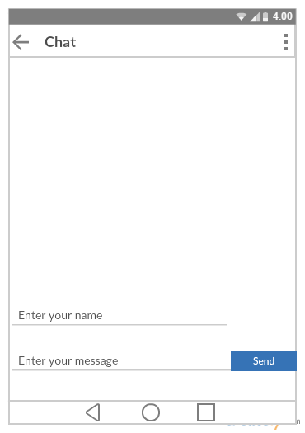

**4.2.2 User Stories:**

**Class diagram:**



**Software architecture diagram:**



**Sequence diagram:**



**4.3. Implementation:**

**Home page for application:**

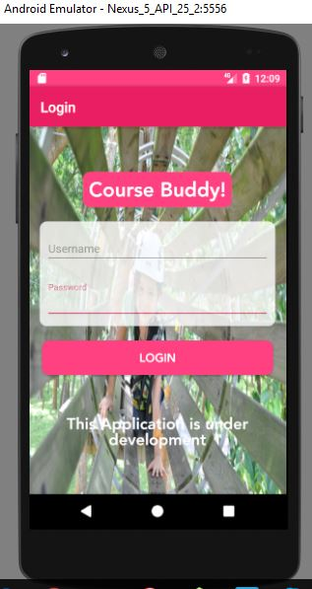

**On successful login, we would get the option to choose the course:**





**On selecting the course, we would get an option to talk with anyone: **



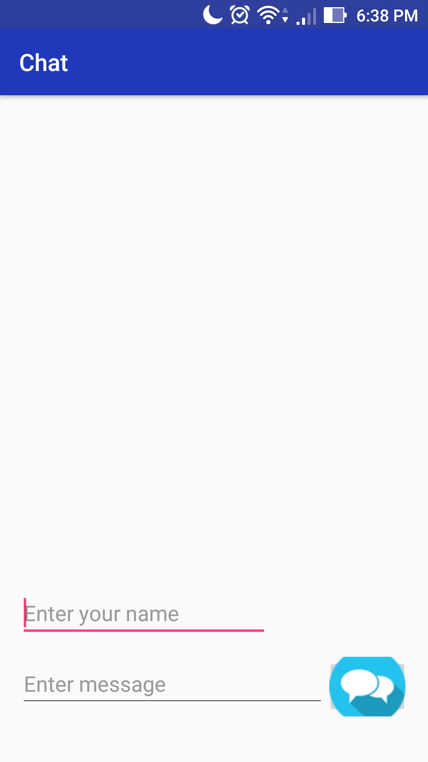**On selecting the option, A chat Screen opens up.**

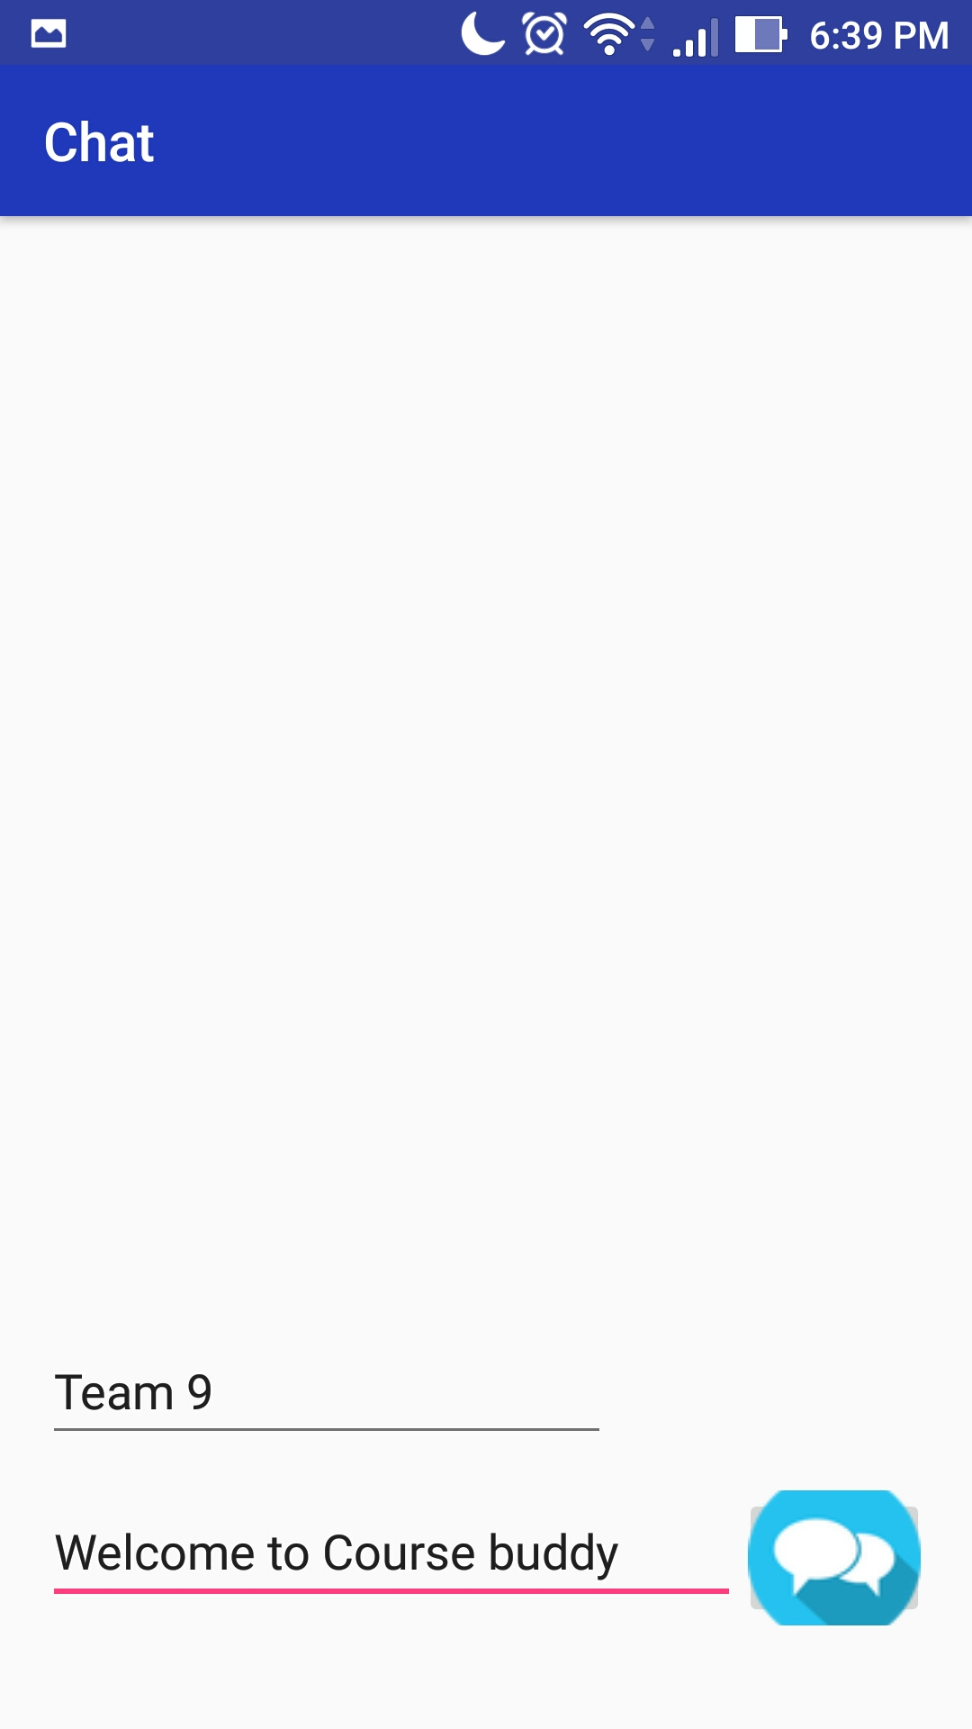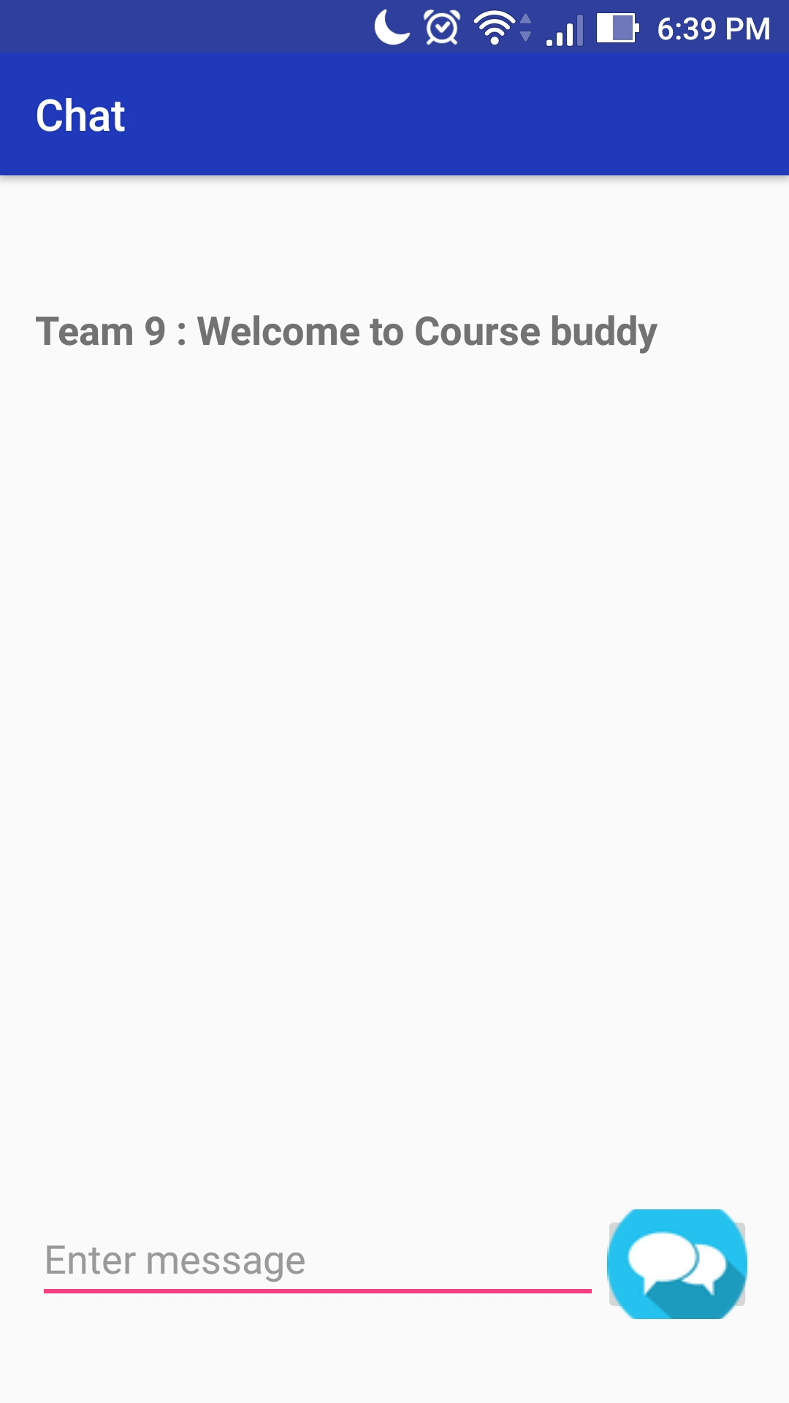

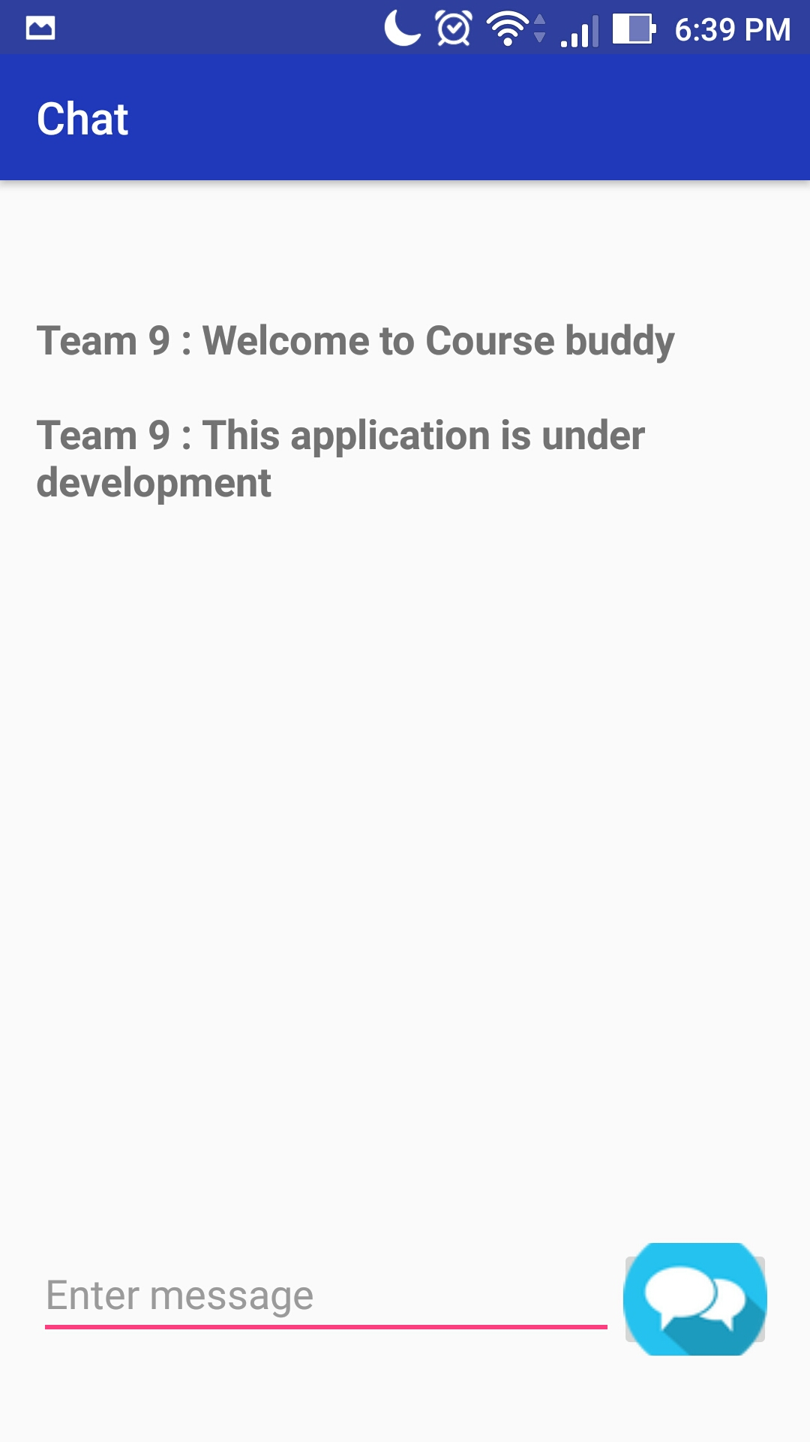

**4.4. Unit Testing:**

The below are the unit cases for second phase of the project:

|  |  |  |  |  |
| --- | --- | --- | --- | --- |
| s.no | Test case title | Description | Expected outcome | Result |
| 1 | User login verification | The user should provide valid email id and password to login. | Upon successful login, user needs to be moved to home page | Pass |
| 2 | User login validation with invalid credentials | User will enter wrong credentials | As the user have entered wrong credentials, access should be declined. | Pass |
| 3 | User login verification without details | User will not enter any credentials. | User should not be granted access as he had not entered any credentials. | Pass |
| 4. | Correct navigation to choosen page | User will give login credentials | Upon successful login, the page should navigate to course selection page | Pass |
| 5 | Navigation after choosing the course | User will select the course he is enrolled in | Upon choosing the course, user needs to be navigated to talk with tutor, ta and discussion forum page | Pass |
| 6 | Navigation to Chat Screen page | User will select the option to either talk with tutor or TA or to engage in discussion forum. | Upon Choosing the Option, User needs to be navigated to Chat Screen page. | Pass |

**4.5. Deployment:**

We have deployed our application on an emulator as well as on Device and have taken screenshots.

We have explained about implementation in detailed in the above sections.

GitHub link for source code and documentation :

**4.6. Project Management:**

**Technologies used: Android SDK, JAVA SDK.**

**Software used: Android studio.**

**In this increment we have completed the following work:**

UML DIAGRAMS

Created increments in Zen Hub

Created wireframes using creately.

Login form modified with material design

Used spinners for drop down of courses and chat options.

Added linear layout with the material design of the screens login, courses, connect activities.

Added navigation.

Courses and Options page.

Implemented Chat Screen.

**Contributions:**

**Vamsi Krishna Challa: 33.33%**

**Shankar Pentyala: 33.3%**

**Girish Kumar Reddy Nagella: 33.3%**



**PROJECT INCREMENT -3 REPORT**

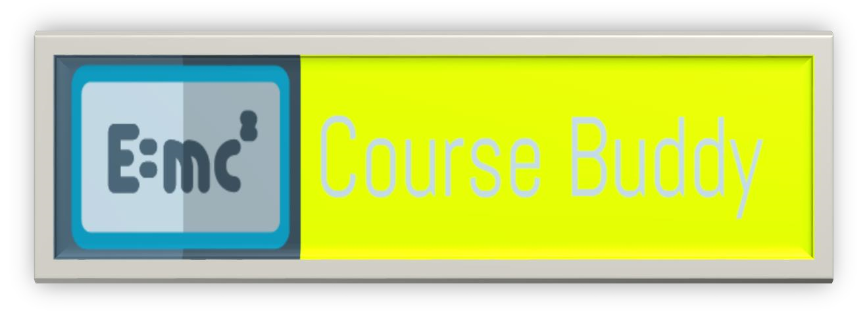

**CS5551 – Advance Software Engineering Project**

**Application Name: “COURSE BUDDY “**

**TEAM NUMBER: 9**

**TEAM MEMBERS:**

**VAMSI KRISHNA CHALLA**

**SHANKAR PENTYALA**

**GIRISH KUMAR REDDY NAGELLA**

**INTRODUCTION:**

COURSE BUDDY

Course buddy is an interactive application which acts as lifeline between students and the teaching fraternity. Student fraternity has a tendency to work along deadlines and many of the times, they tend to forget the deadlines and lose marks even having competency to complete on time. Not only deadlines, many of the student fraternity has a feeling of introvert of not being able to directly interact with the teaching fraternity.

Our COURSE BUDDY application tries to lessen the gap between teaching and student streams and also provide an interface for free flow of communication. Giving it a social media touch, would easily attract the students to make use of it.

Many times we face difficulty in finding out means to talk to our teaching faculty because of lack of availability of information. Myself, I am example how a student face difficulty in reaching faculty to break many barriers regarding the subject. As an international student, I was very much astonished at the etiquette of the college and I pulled myself backward from making a step ahead to clear my doubts regarding subjects. In the initial days, I was not able to find means of communication to reach out the faculty to be able to clarify my doubts regarding the subject and course curriculum.

So goes a saying, “Failure is the stepping stone of success.” As a blind follower of that, we tried to utilize this project opportunity to build an interface that would address the problems faced by us.

**Project Goal and Objectives:**

**2.1. Overall goal:**

Our primary goal is to develop a hybrid application “COURSE BUDDY” which is an interface between students and faculty. This interface is made using android software development kit and various other services which are needed for smooth running of applications.

**2.2. Specific objectives:**

Course buddy is used purely for educational purpose. Students login into the application to be able to talk with tutors, teaching assistants and also their course buddies without compromising their privacy

**2.3. Specific Features:**

Not compromising student’s privacy:

Many doubts of students can actually be solved by talking with their friends. But in an international institution we may not be able to easily mingle with students. Our course buddy would create a discussion forum without disclosing student’s identity and it would facilitate the student to clarify their doubts easily.

Talk with tutors and teaching assistants on a single platform: Instead of using mail based communication to reach out to professors and using mail based or spreadsheet based communication to reach out to teaching assistants, this interface provides a unique platform to reach out both at a single click.

**2.4. Significance:**

This application in creating a healthy environment where learning evolves from different aspiring minds and would help each other to excel themselves by taking help of their professors, teaching assistants and their friends.

**Project Plan:**

**Schedule for different Increments:**

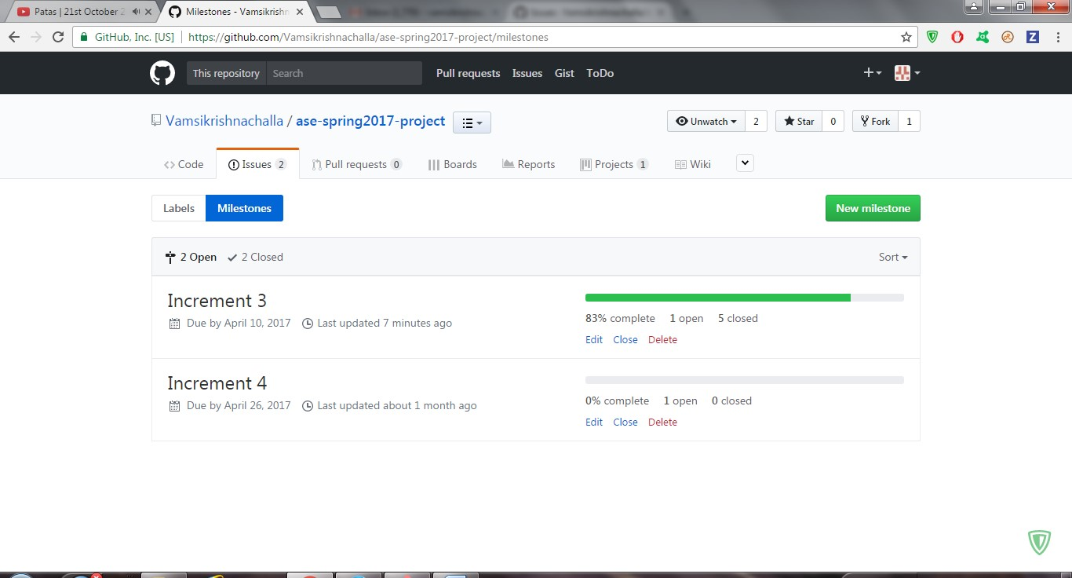

**Project timelines, Members and responsibilities:**

Below are the issues that were created under each increment.

These tasks are assigned to team members.

Once the respective task is accomplished, the issue is moved to closed state.

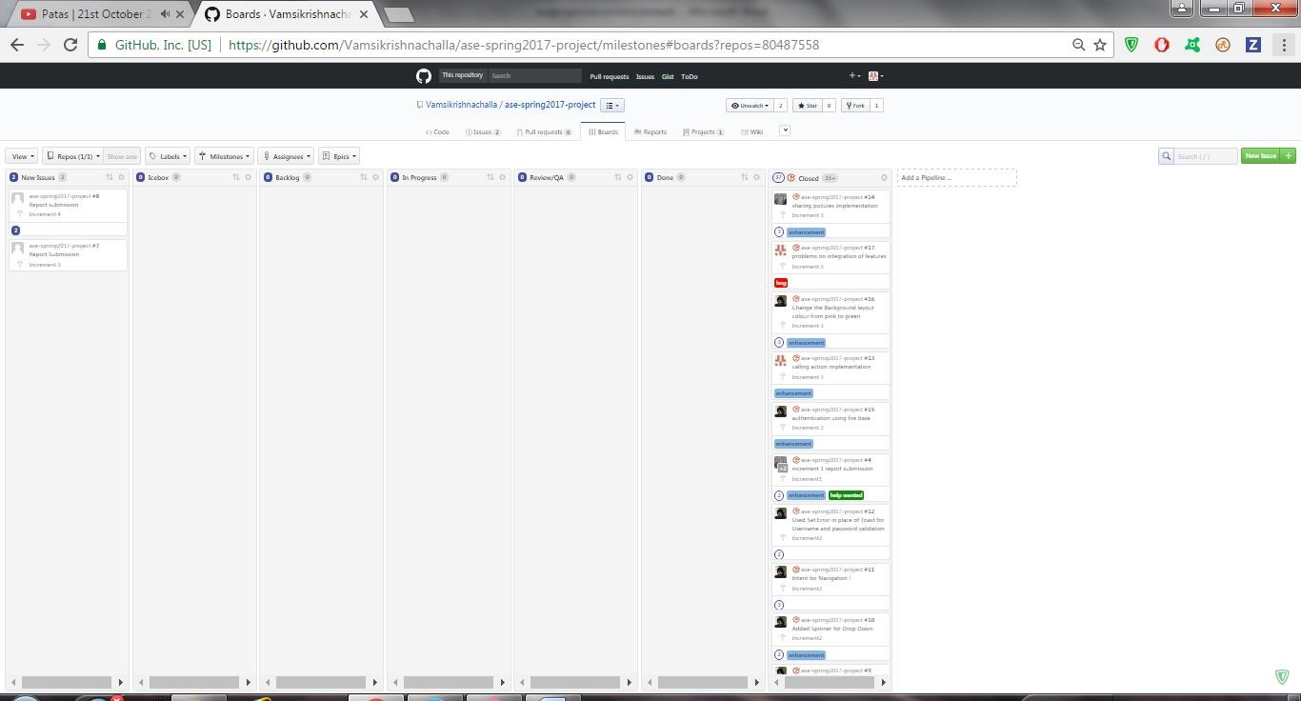

**3.3. Burndown chart:**

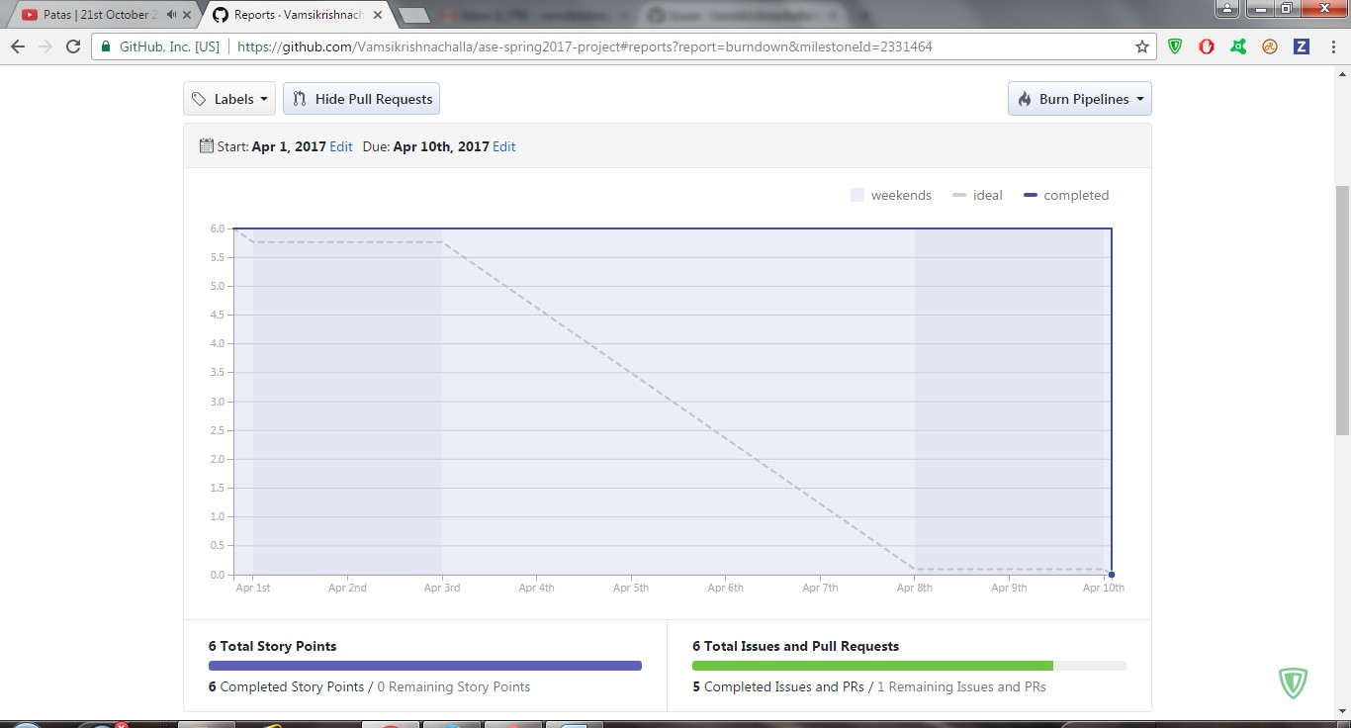

**3.4 Velocity Tracking:**

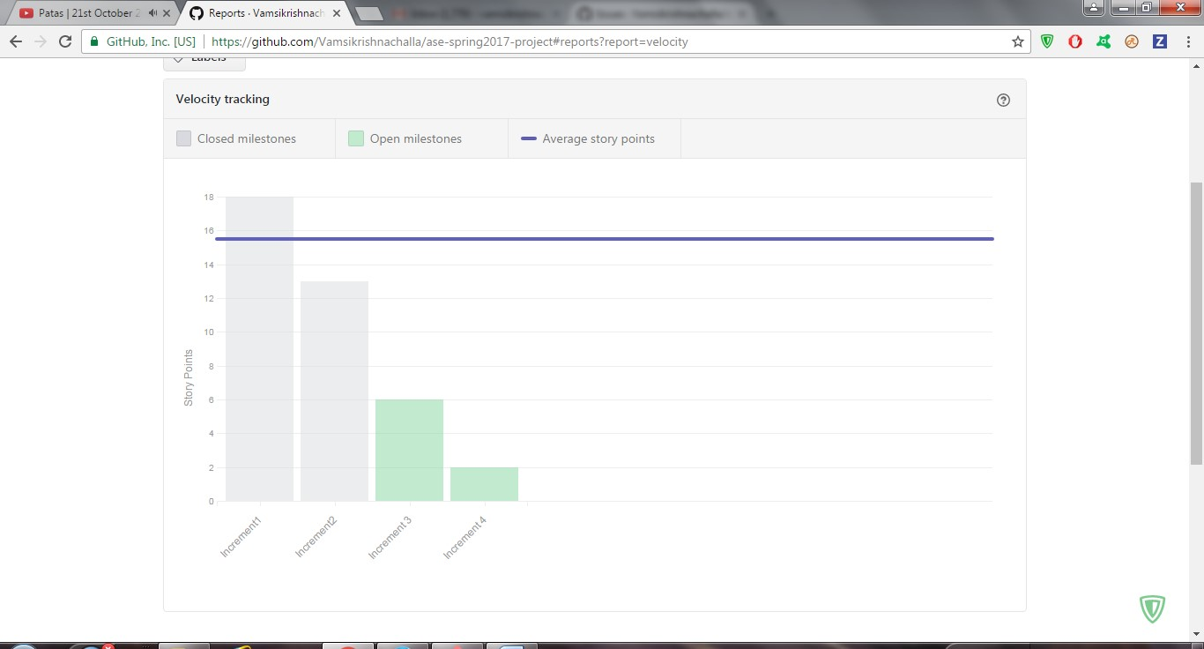

**Third Increment Report:**

In this increment we have designed UI mockups by designing wireframes and by keeping them in mind, we have designed login pages, course selection page and choosing the option to talk with anyone of the professors or teaching assistants or course buddies.

**Existing services / REST API:**

In this current increment, we have used Firebase services. In the future increments, we may stick with firebase or use other services.

**Detail design of features:**

**4.2.1 Wireframes:**

**The wireframes for second phase of project are shown below:**

**Login page: after user opens the application, one would be asked to enter the credentials to enter into the application.**

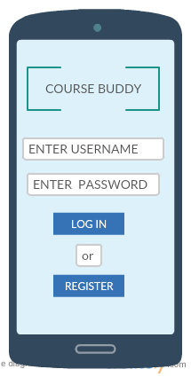

The user should have already be registered i.e., the details of the user must be already available with us as it is related to university and the details of student would be uploaded on a pre hand for authentication.

This wireframe comes once the login is successful.

In this wireframe we will be able to see the options to choose the courses In which we have enrolled.

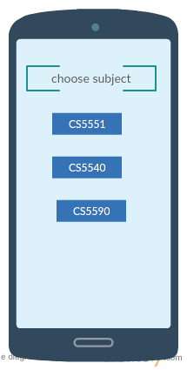

Upon selecting the subject, we would get the option to talk with one of the required persons which we are needed to talk to like:

1. Professor

2. Teaching assistants

3. Course buddies.

This is the wireframe for choosing the option to talk or else log off from the application.

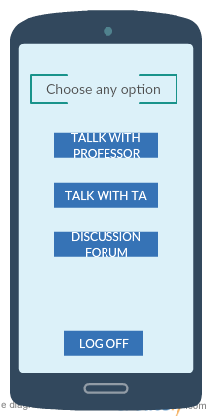

Upon Selecting an option, you will be redirected to chat screen,

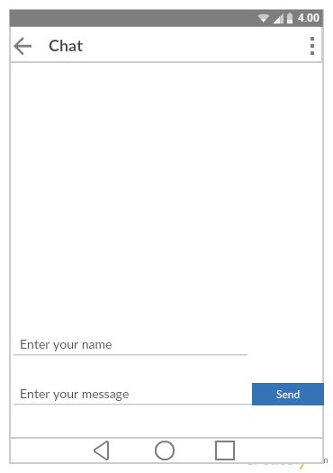

**4.2.2 User Stories:**

**Class diagram:**

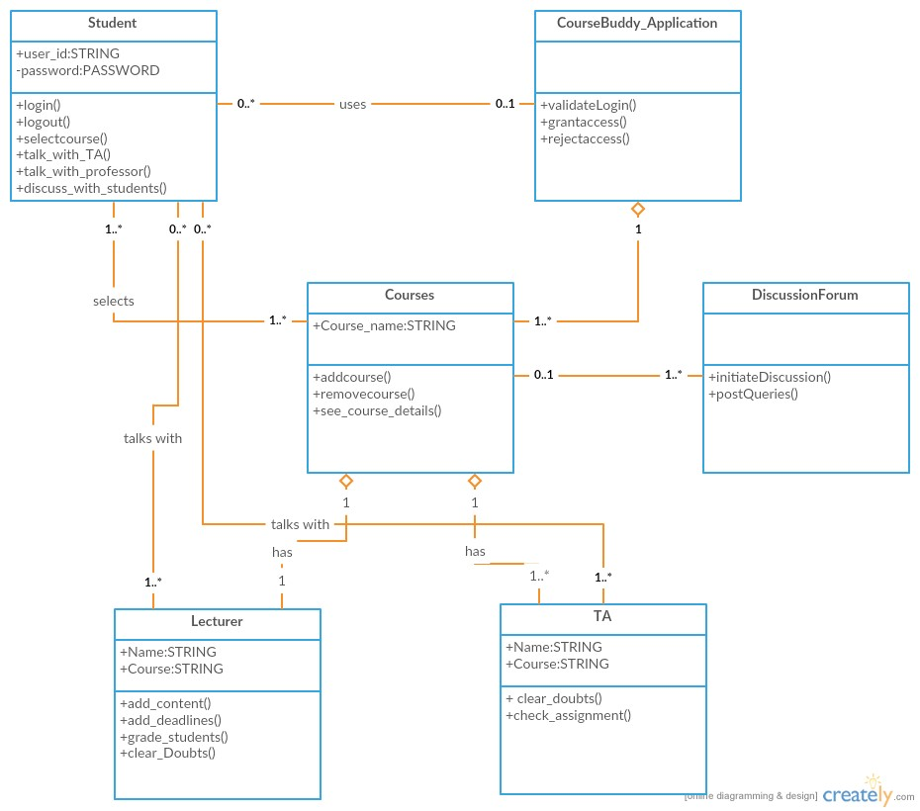

**Software architecture diagram:**

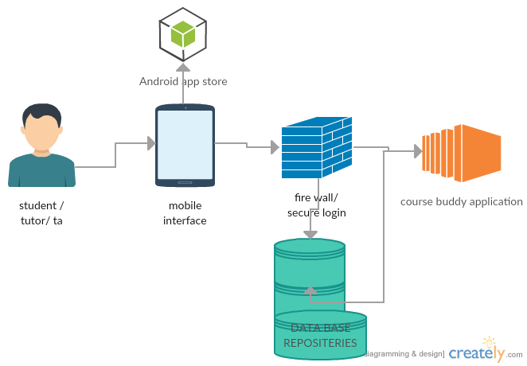

**Sequence diagram:**

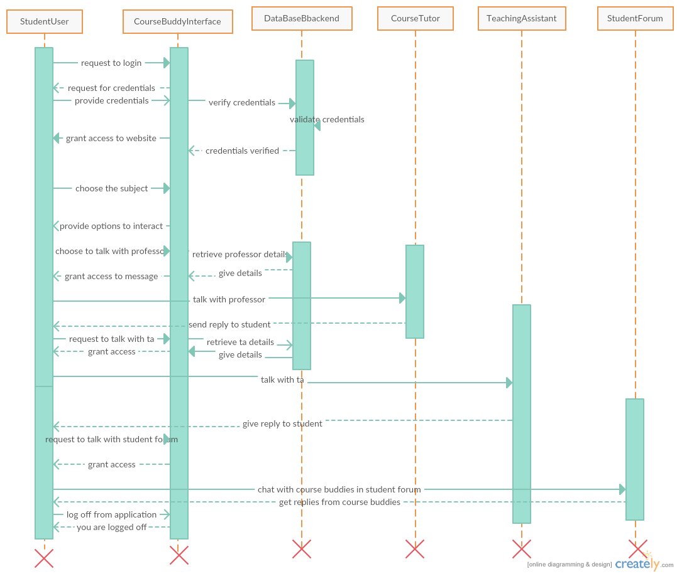

**4.3. Implementation:**

**Home page for application:**

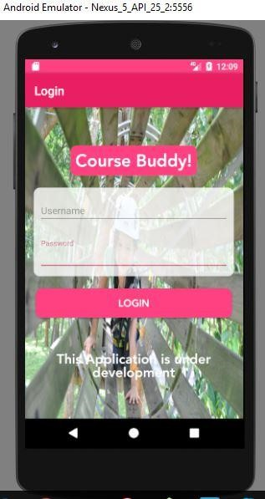

**On successful login, we would get the option to choose the course:**

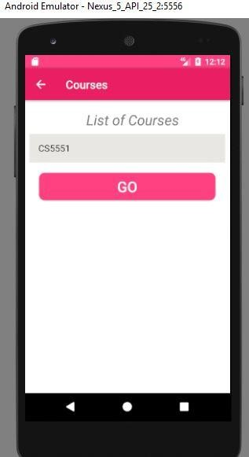

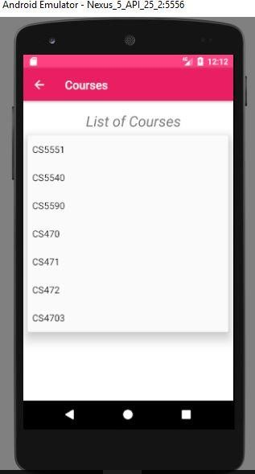

**On selecting the course, we would get an option to talk with anyone:**

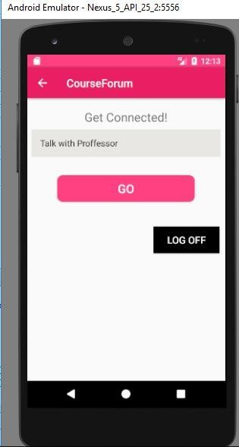

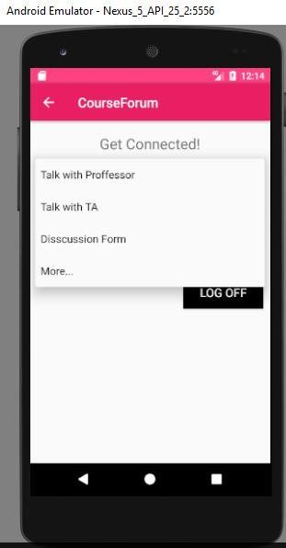

**On selecting the option, A chat Screen opens up.**

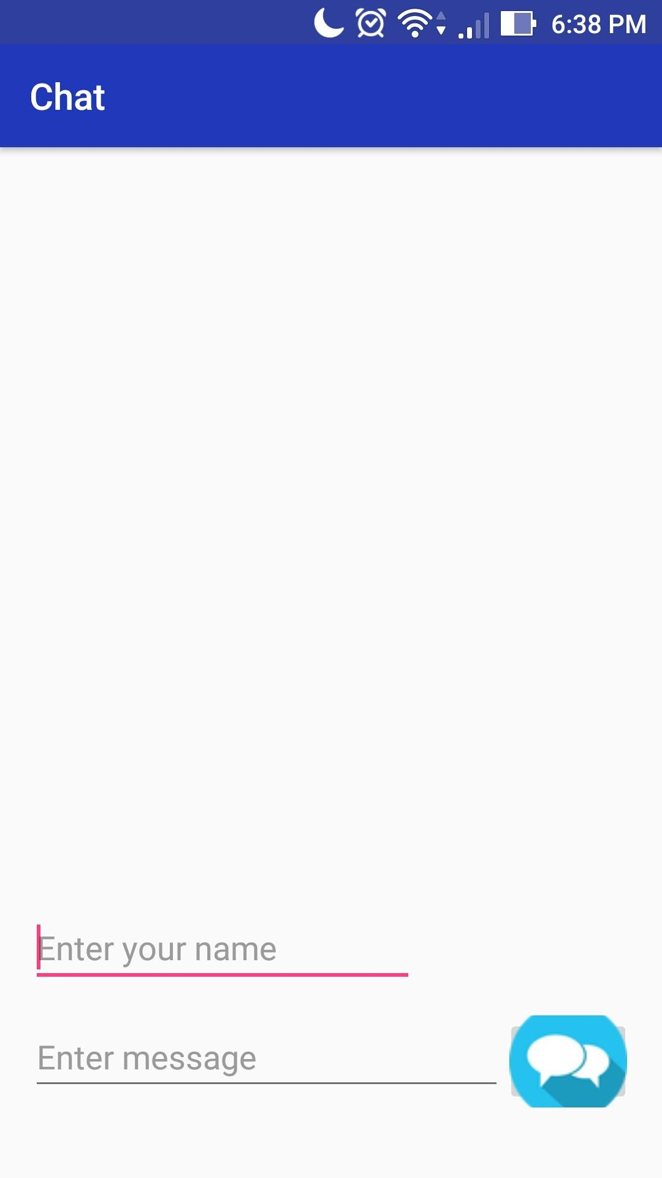

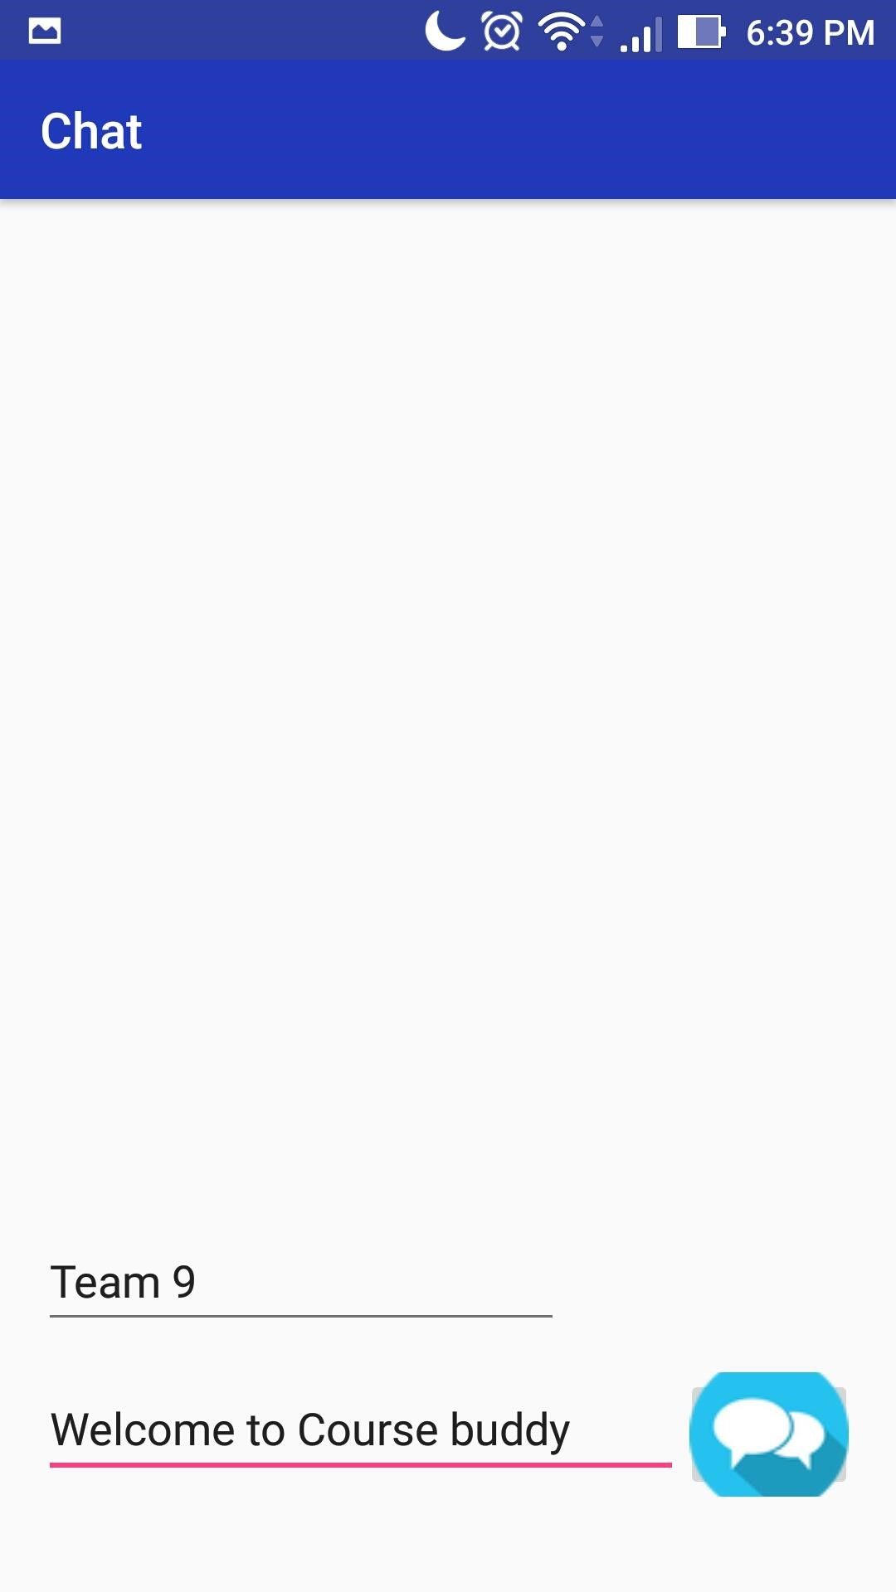

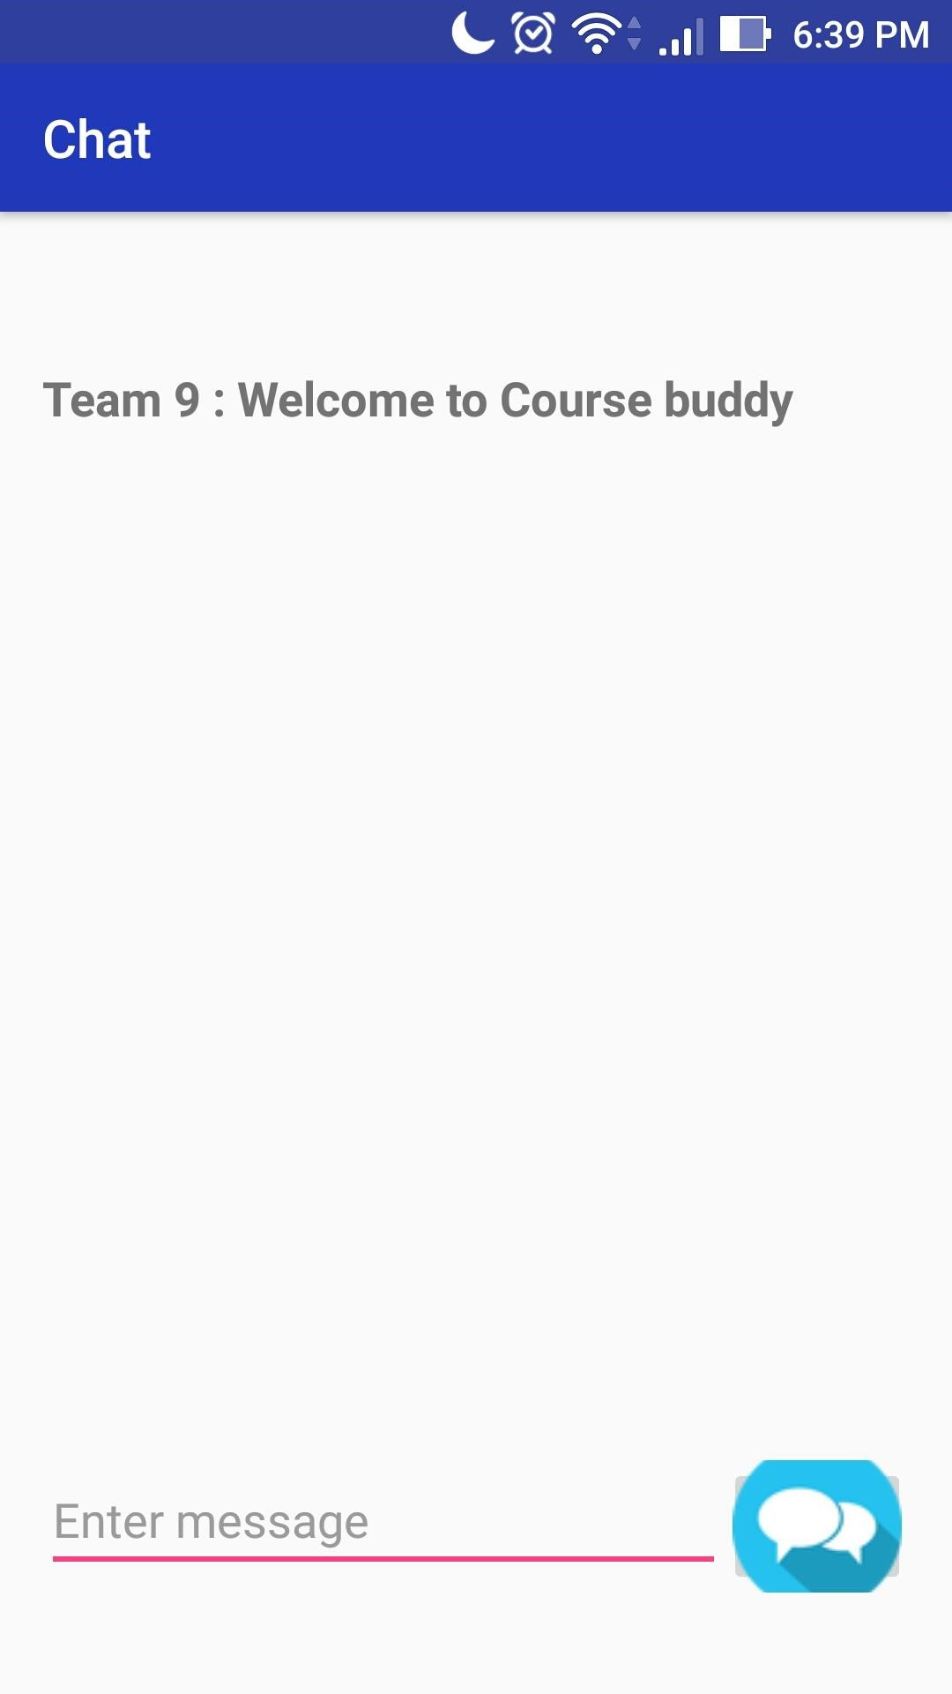

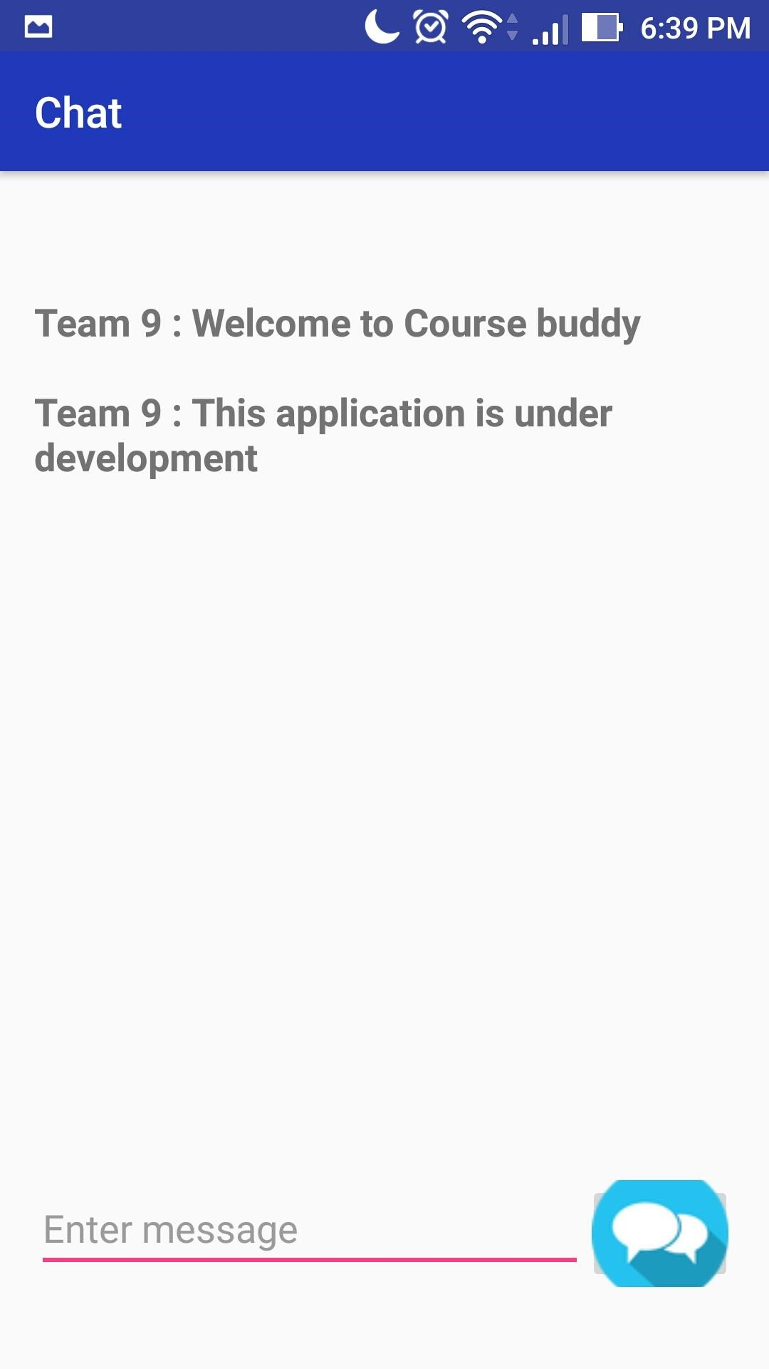

**Enhancements made to the previous versions:**

In this increment we have implemented

Firebase implementation for Chat and share activities.

Below are the screenshots of fire base

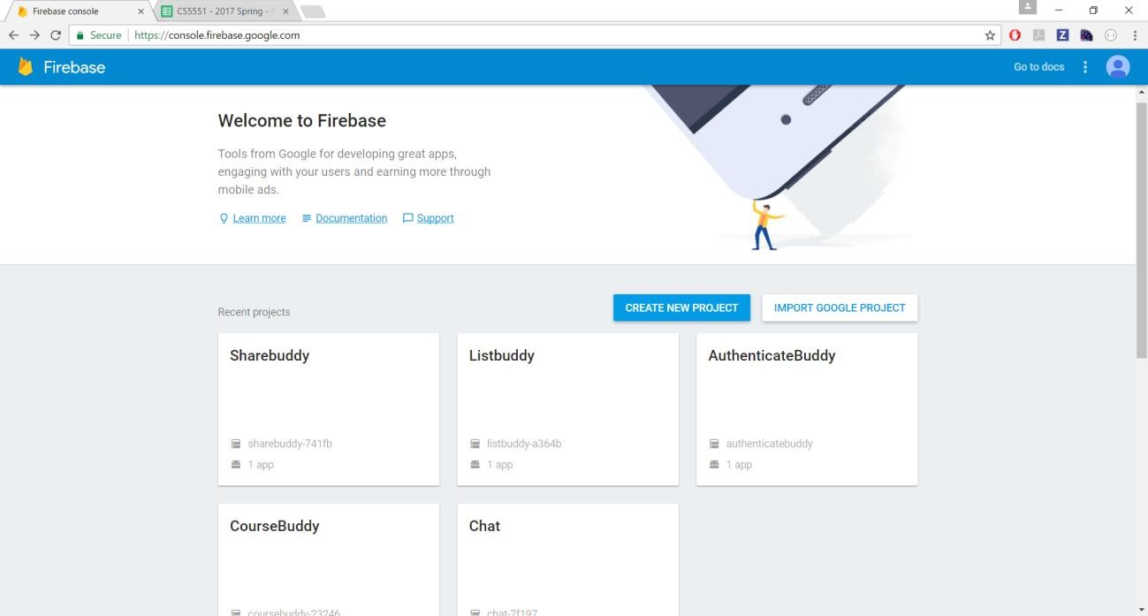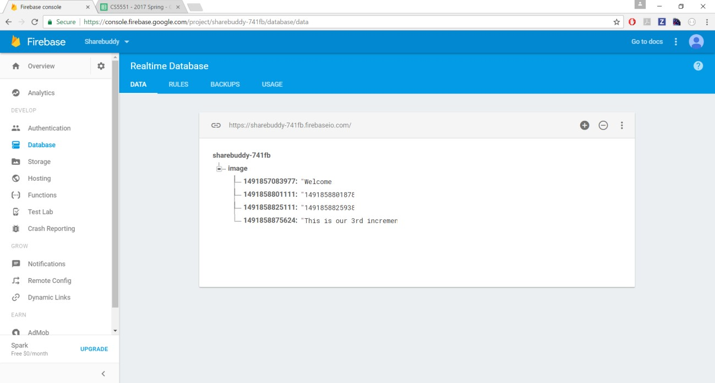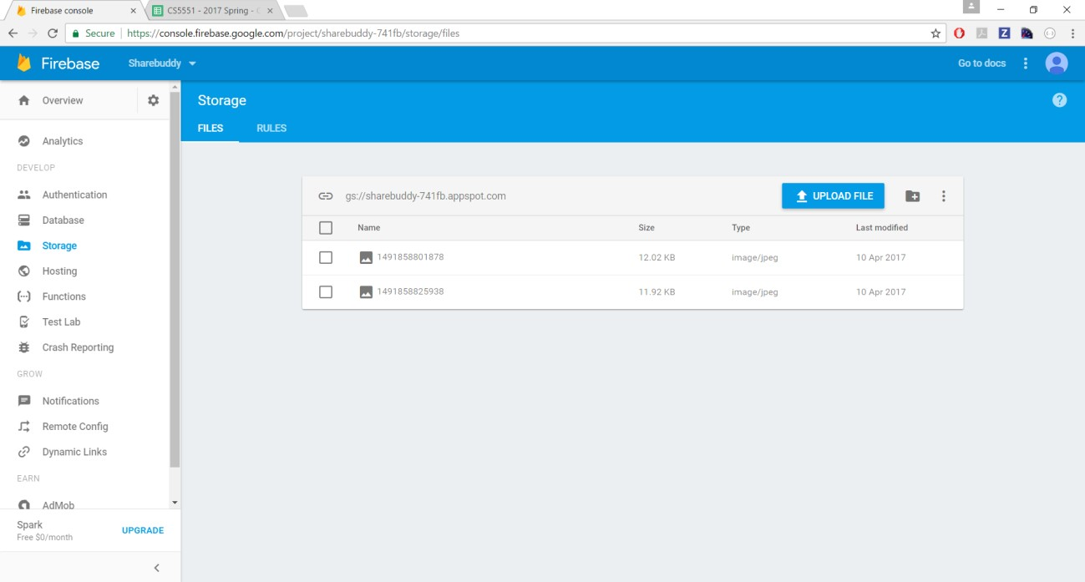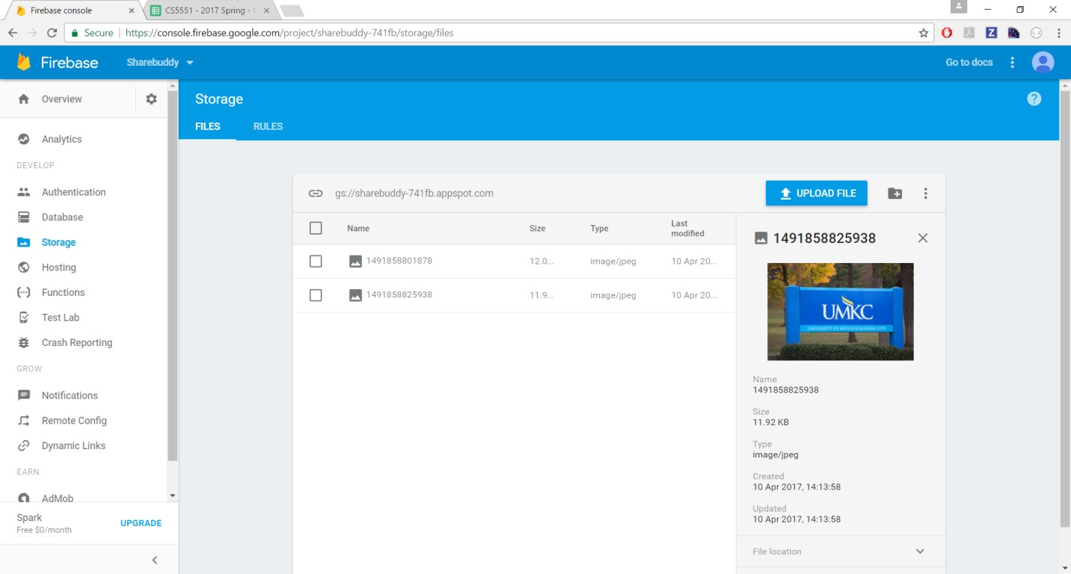

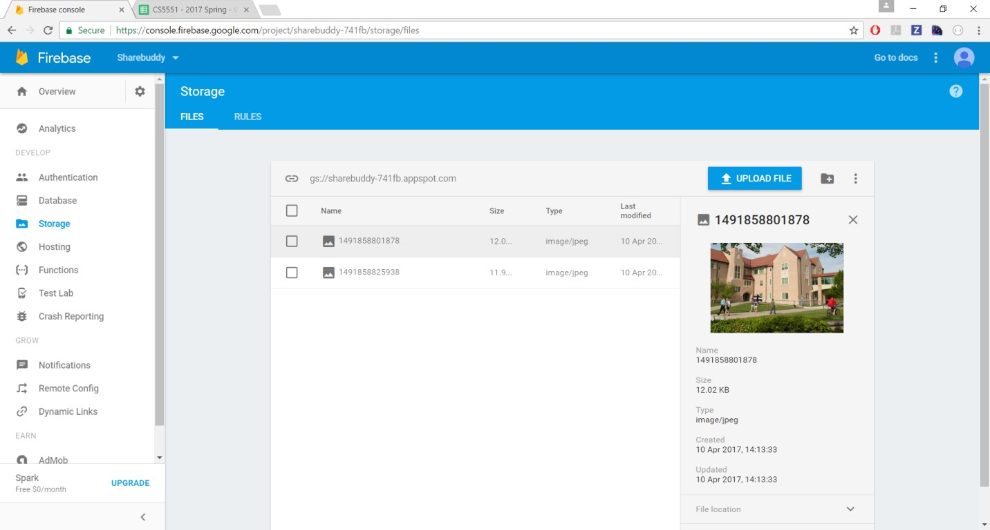

We have also implemented in-app calling feature to be able to call to the other user:

In this step user will be prompted to enter his sso

Now user will be prompted to enter his friend’s sso, sso of his friend with whom he is interested to talk.

Now upon entering friend’s id user will be able to redirect to call screen where he will be allowed to make a call and talk to him.

Upon clicking on call barring button, the call would come to an end.

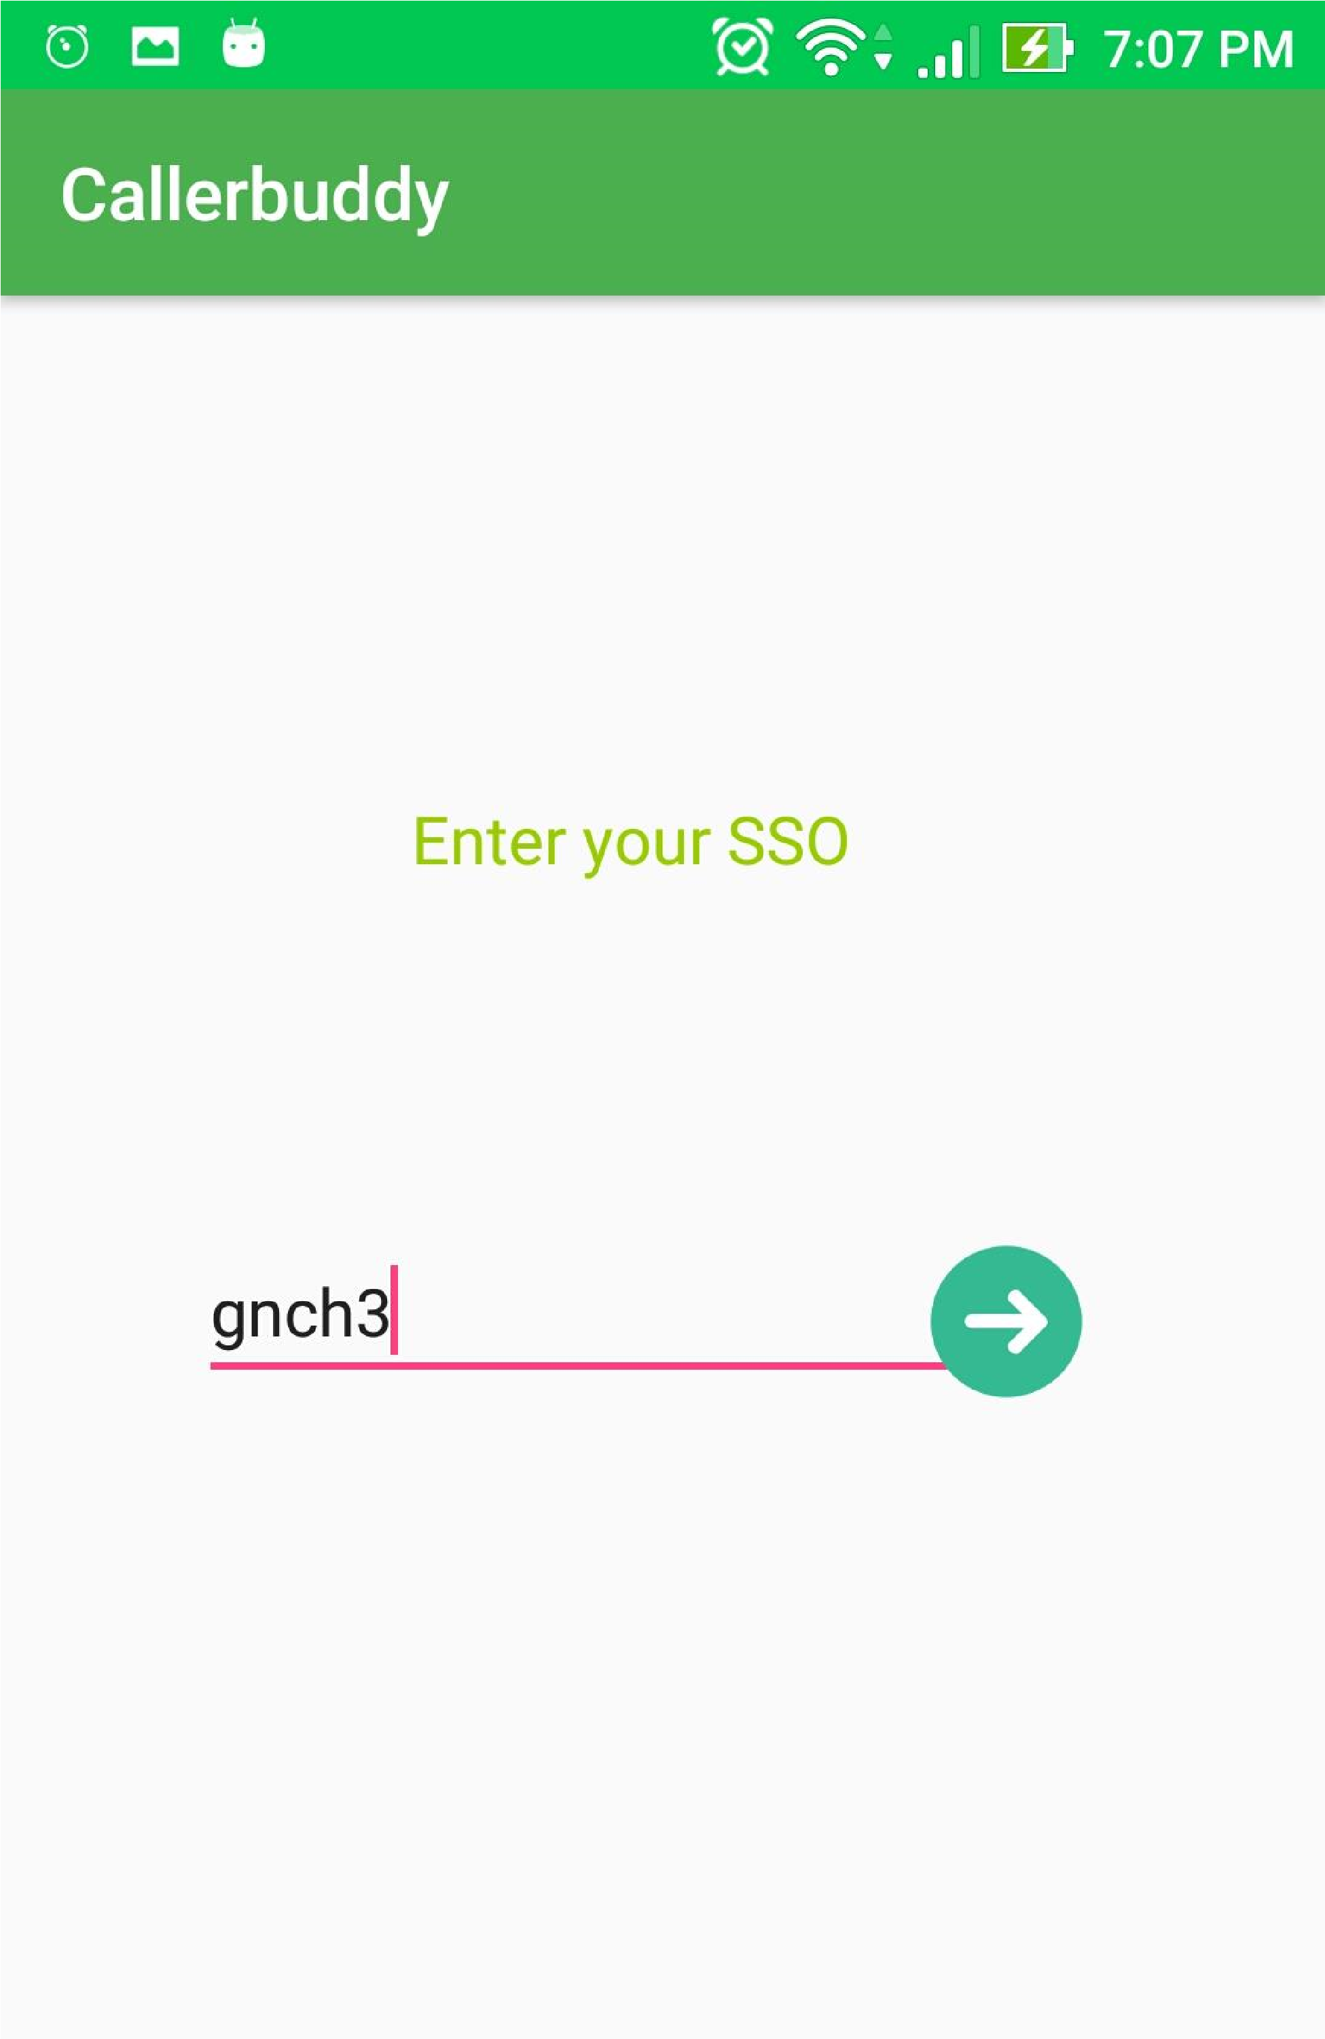

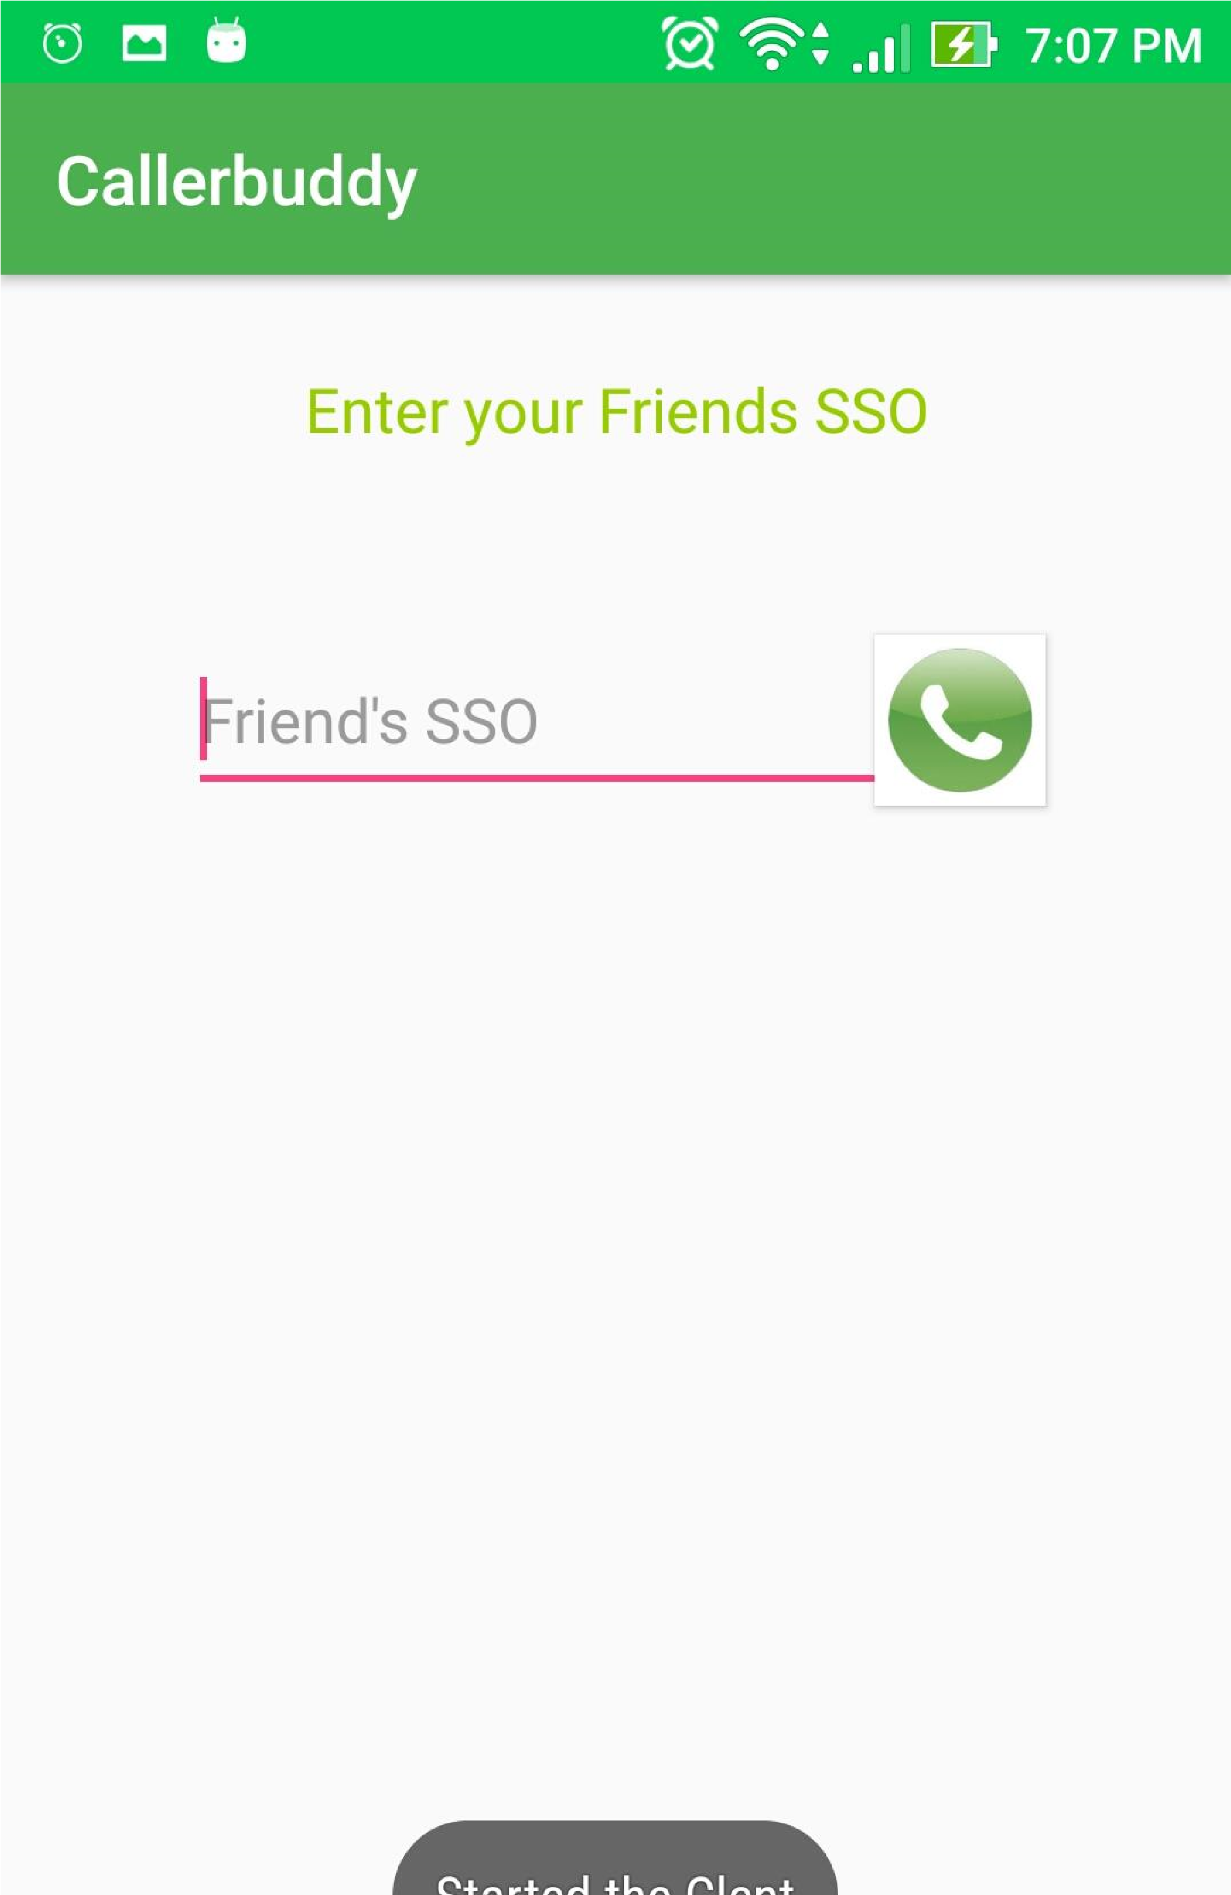

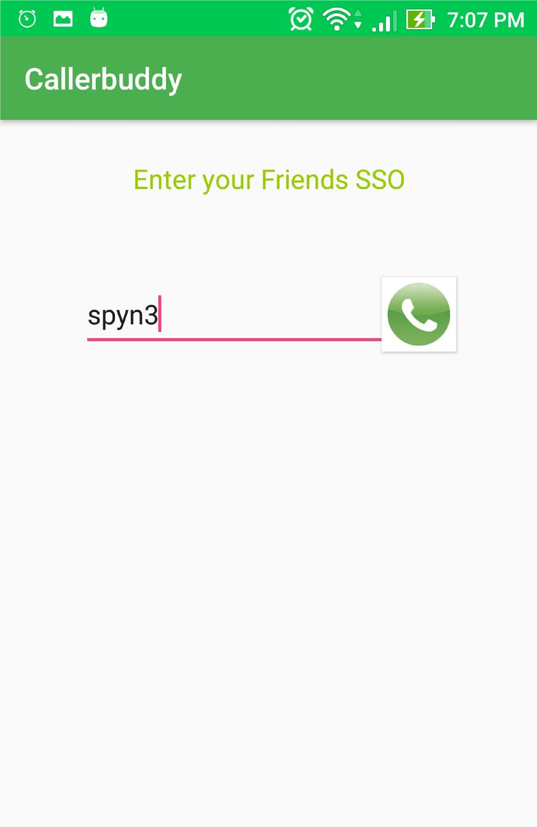

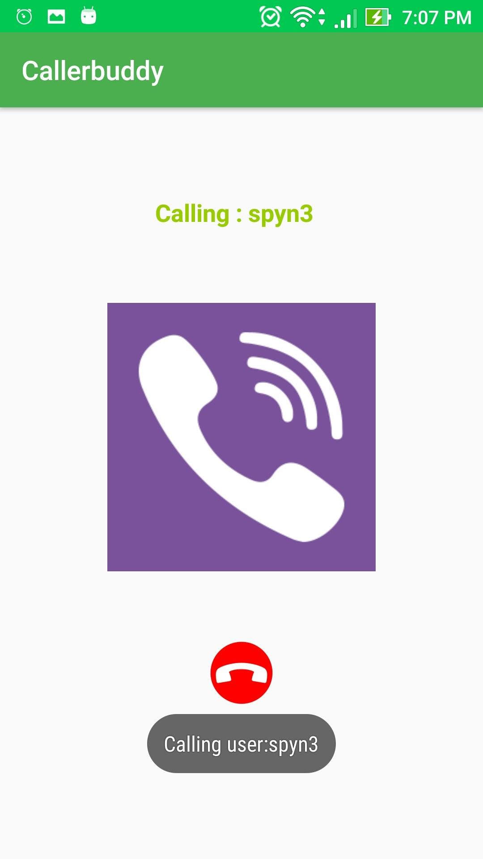

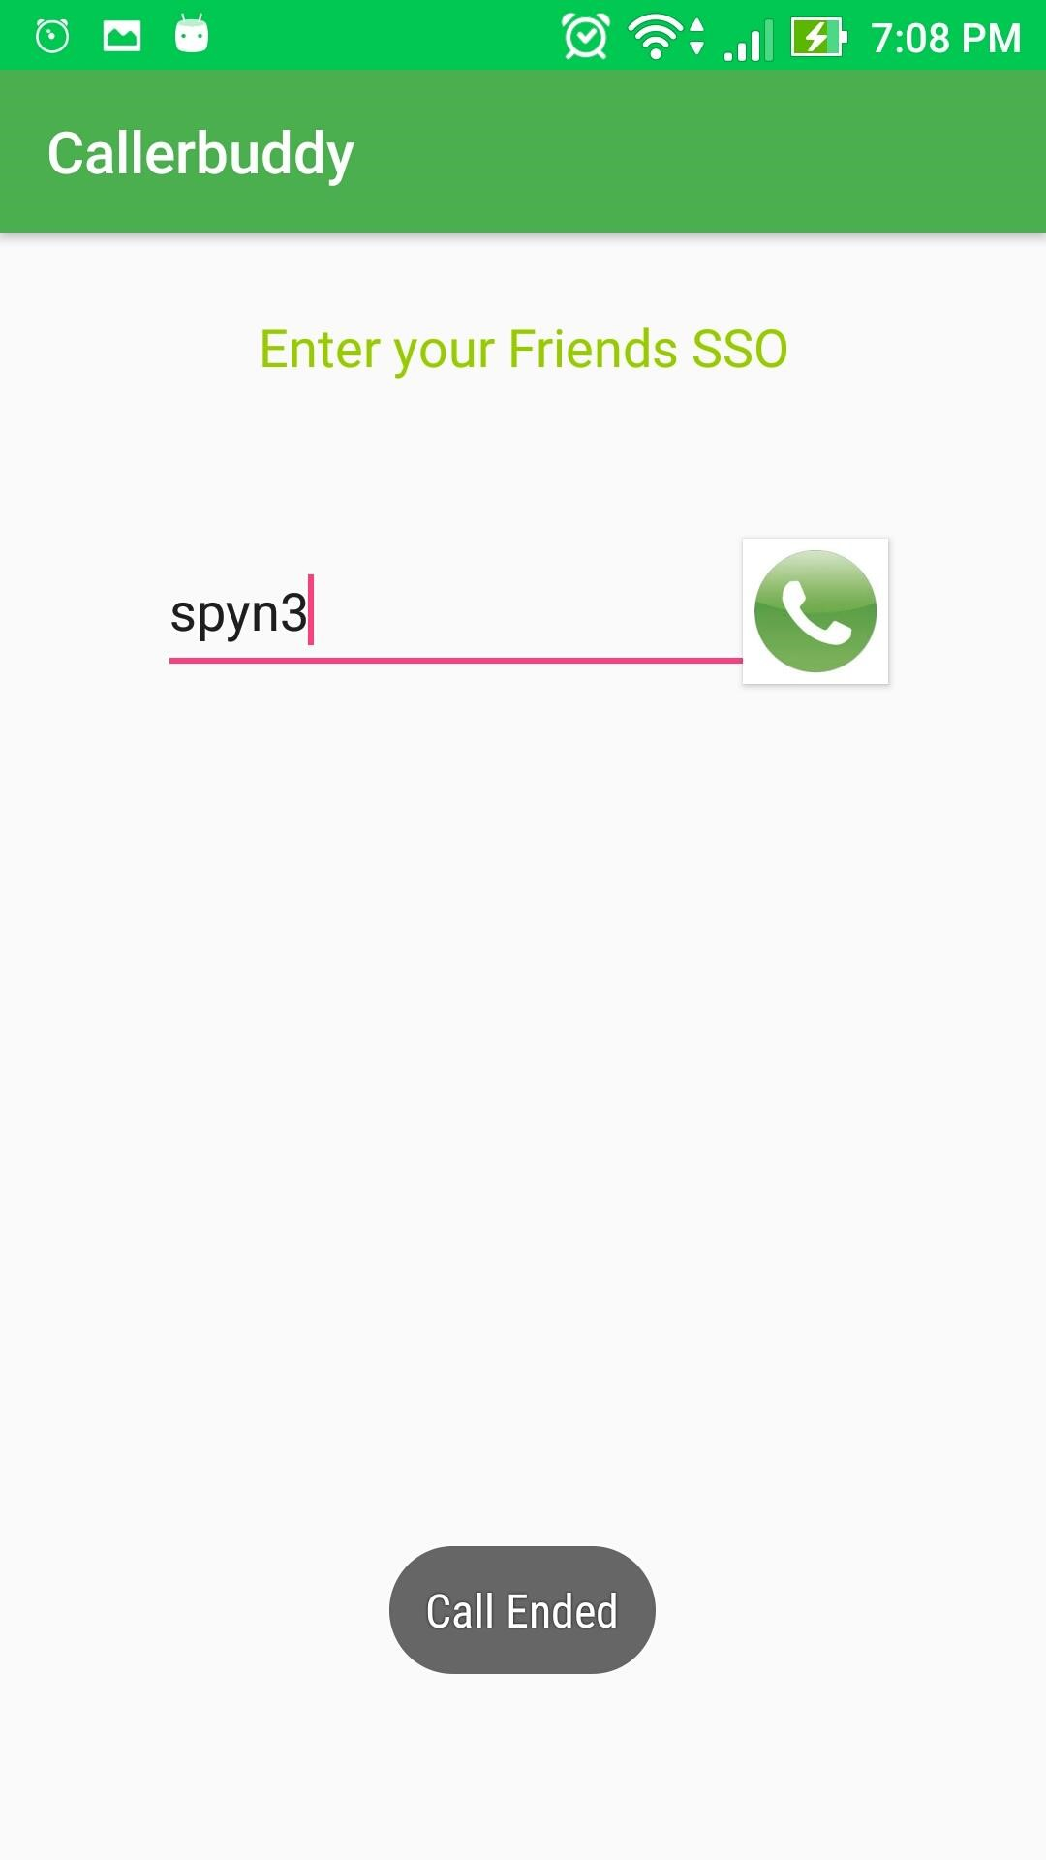

We have also implemented file sharing functionality which allows users to pick an image from gallery and send it to other user:

Upon opening the app, User gets the messages and images from his previous chat.

User can type in his message and tap the message icon to send message to other users.

User can tap on Gallery icon to pick the image he wants to send.

Upon picking the message, User taps on send image to send image to other users.

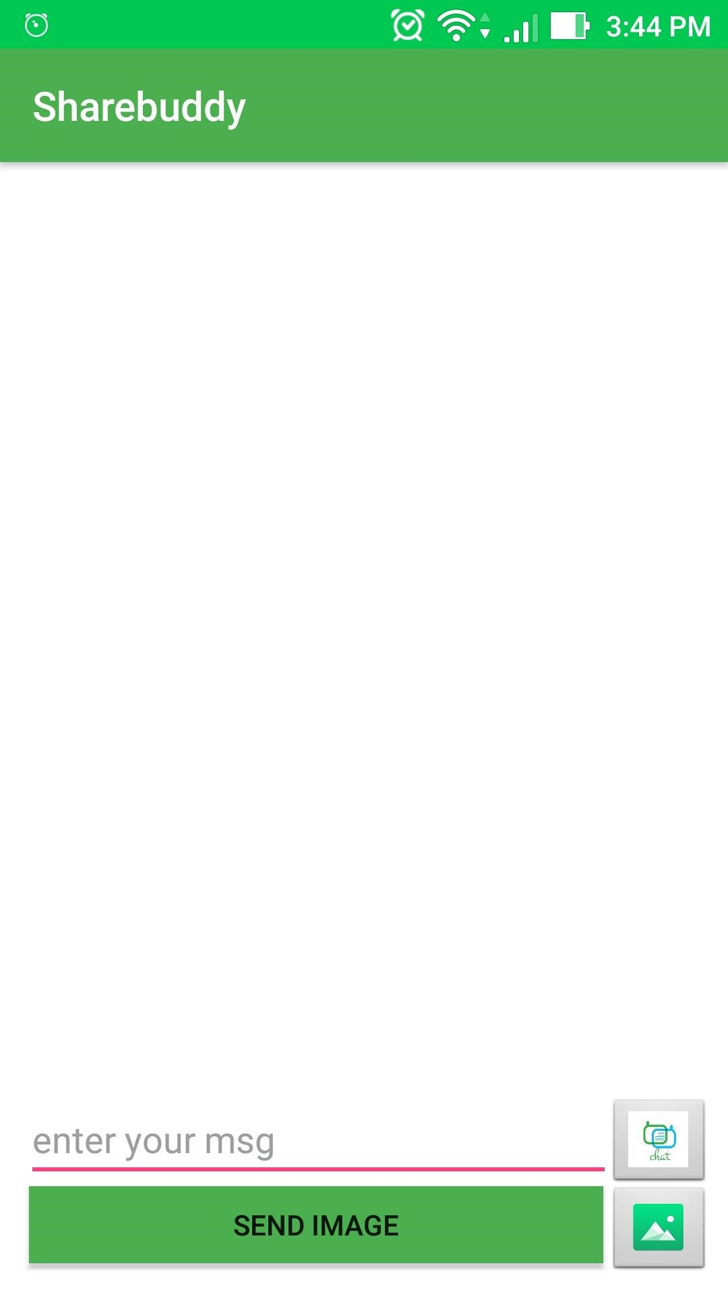

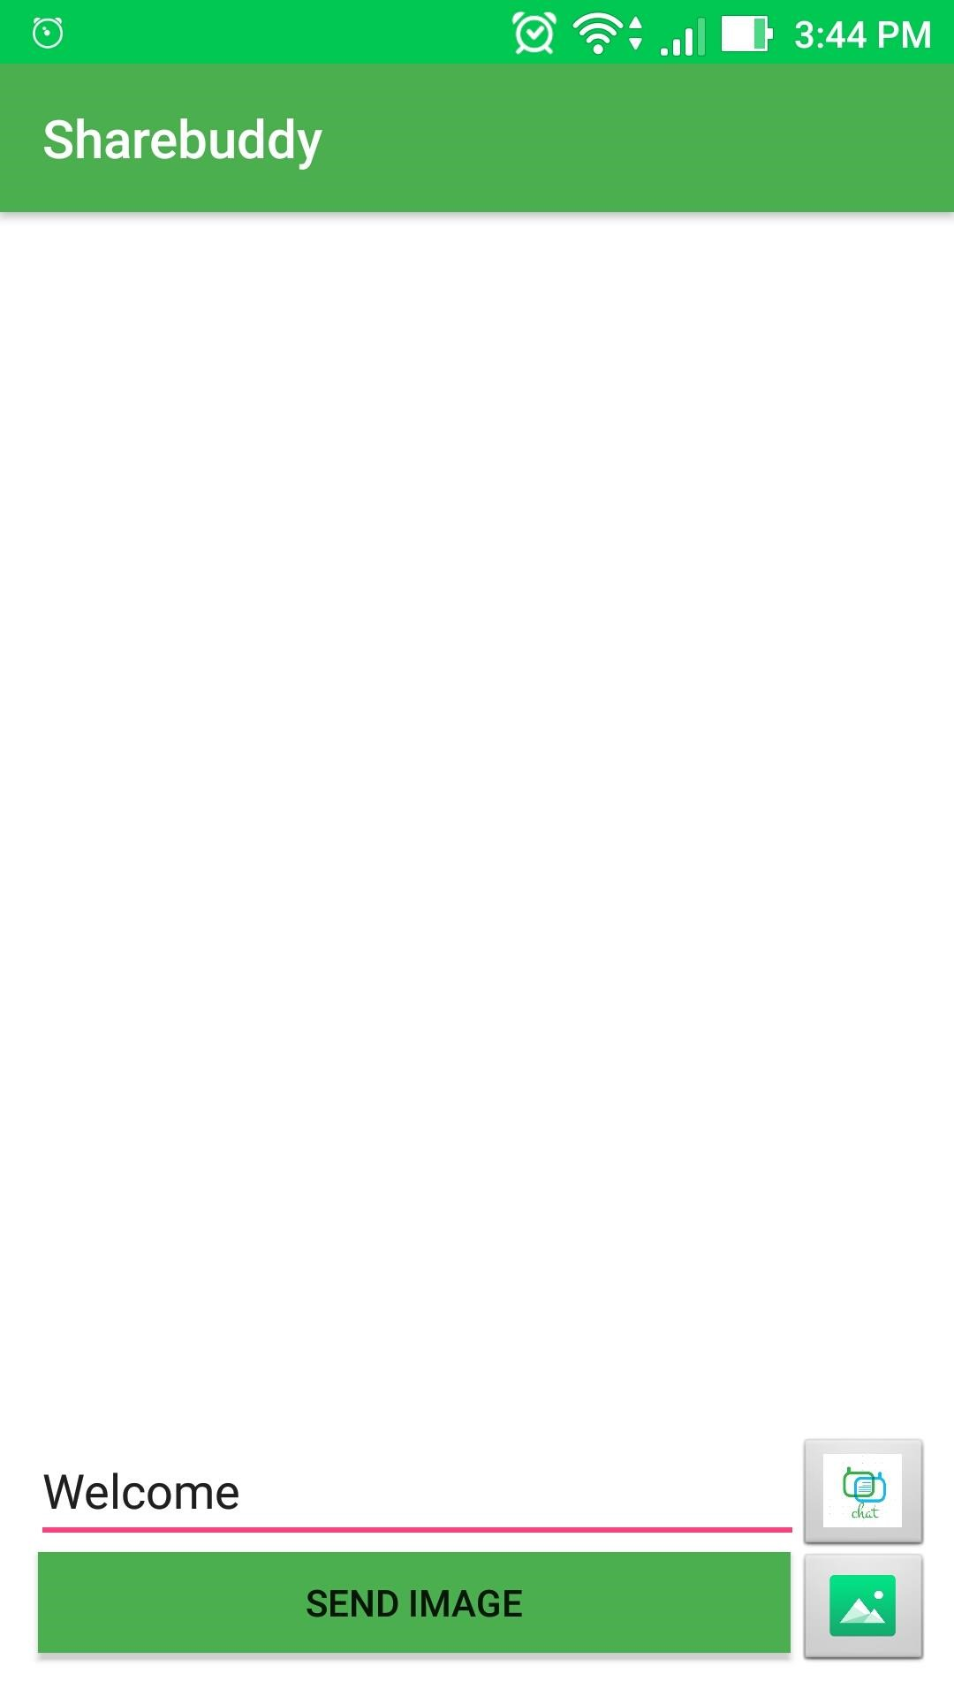

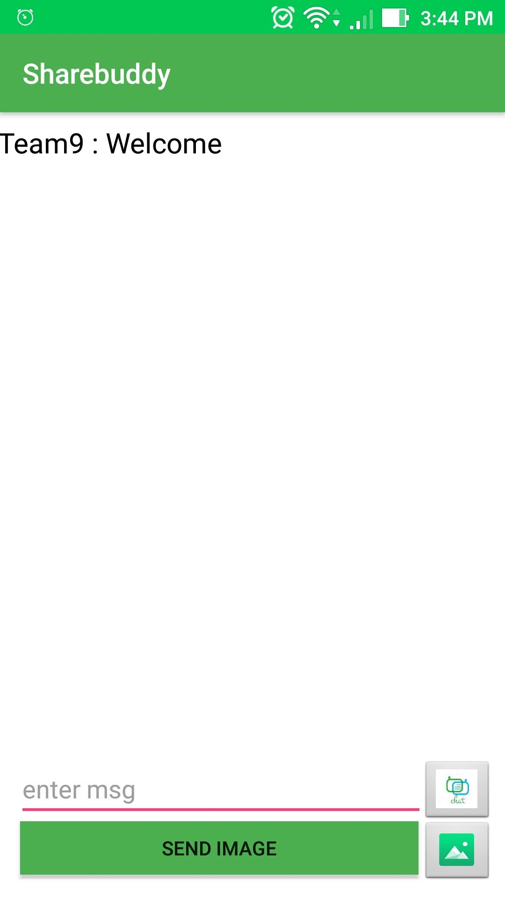

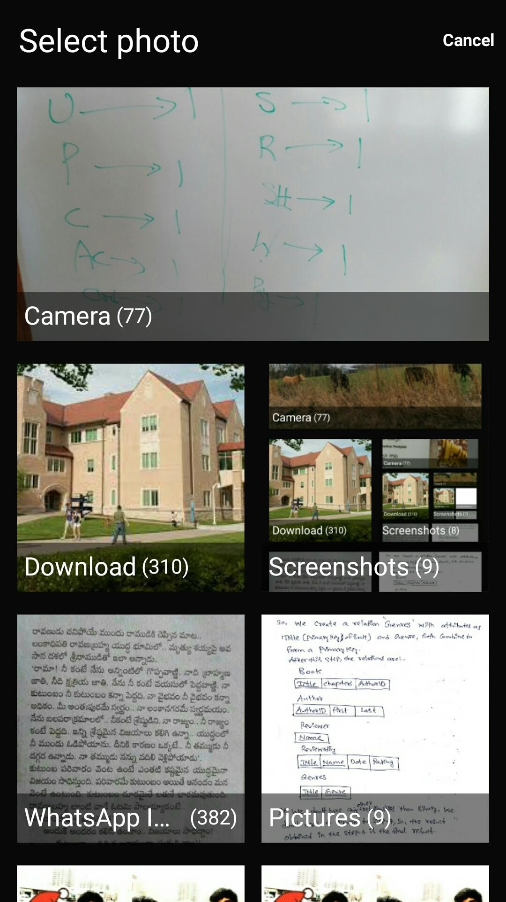

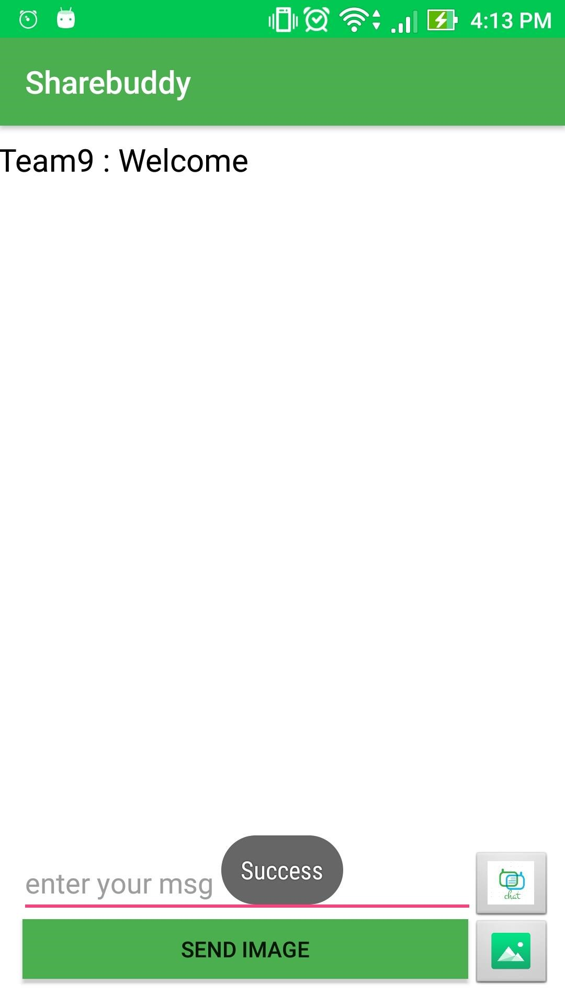

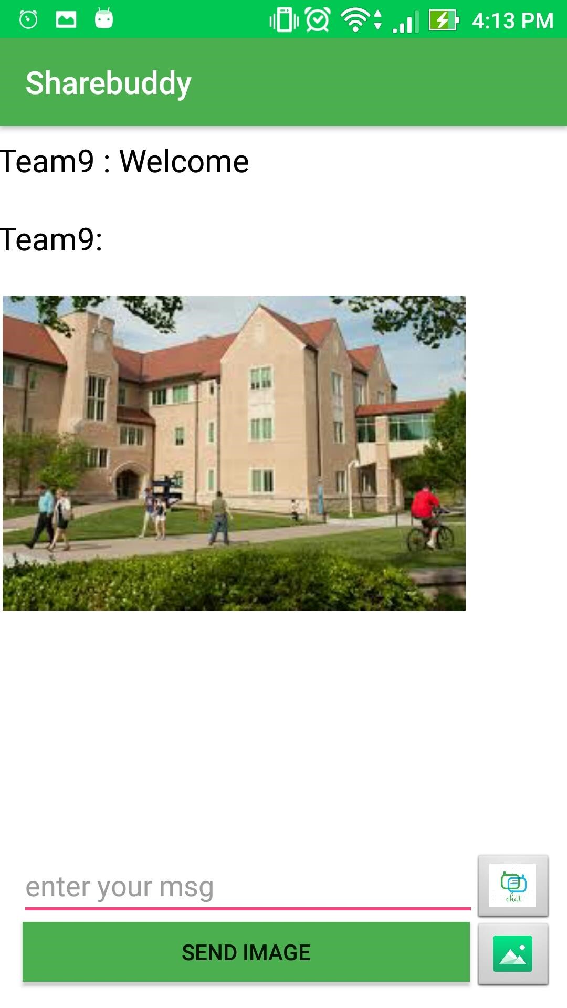

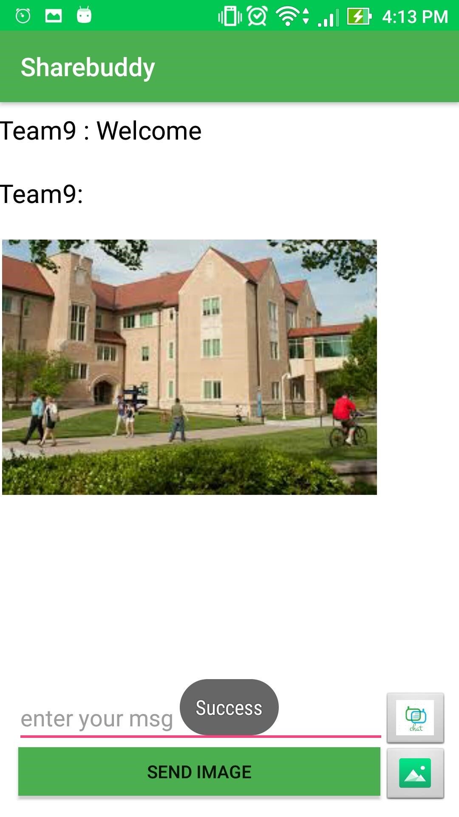

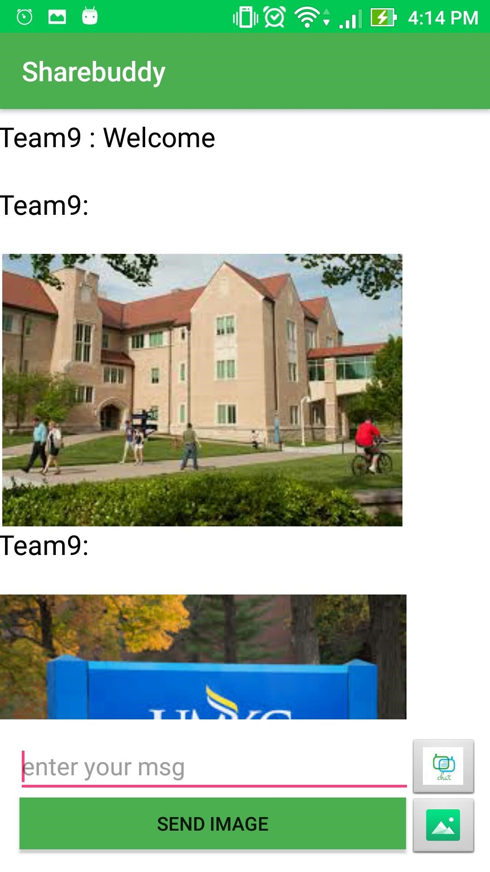

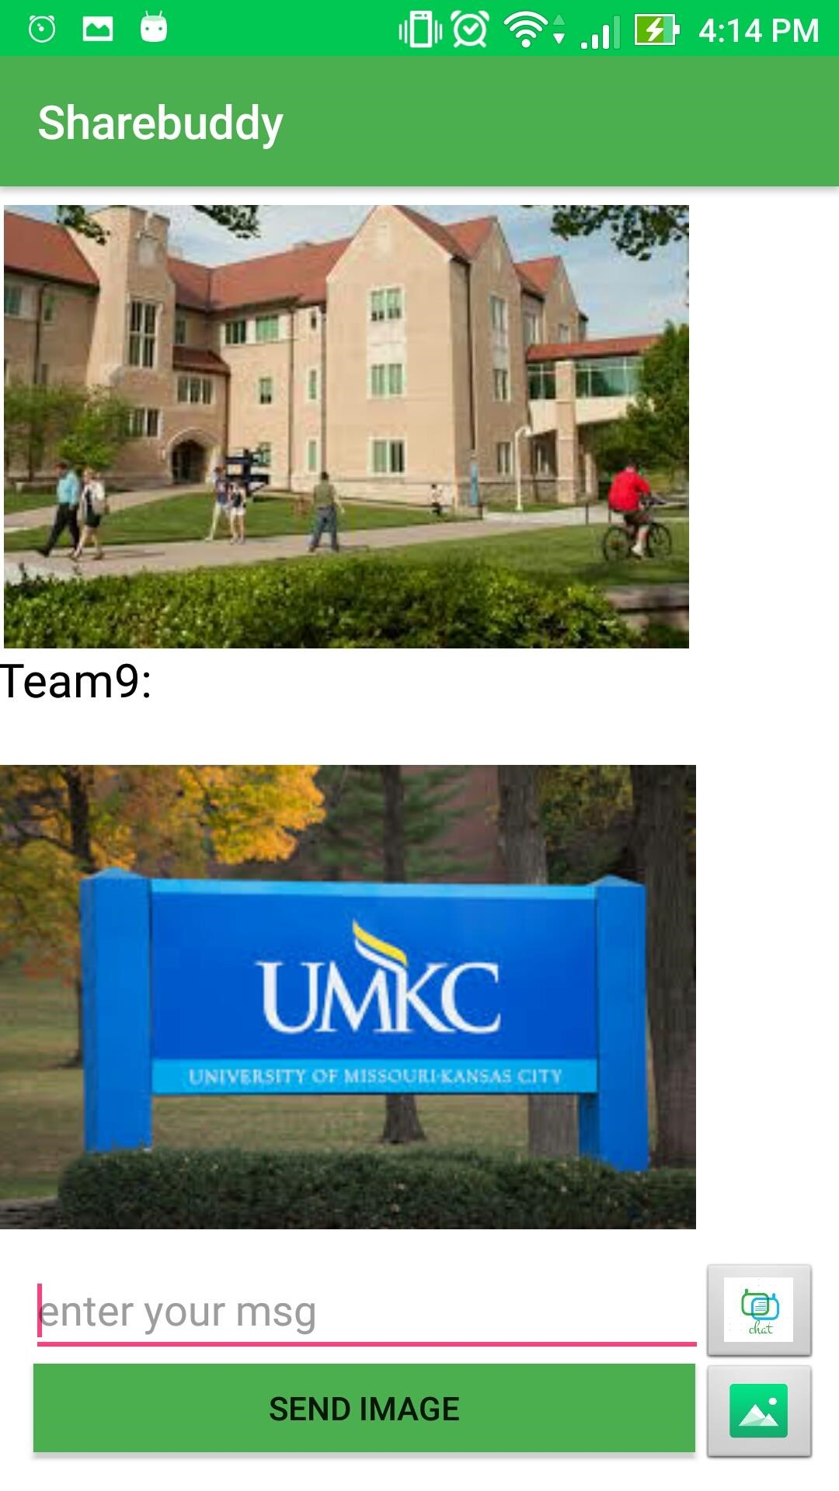

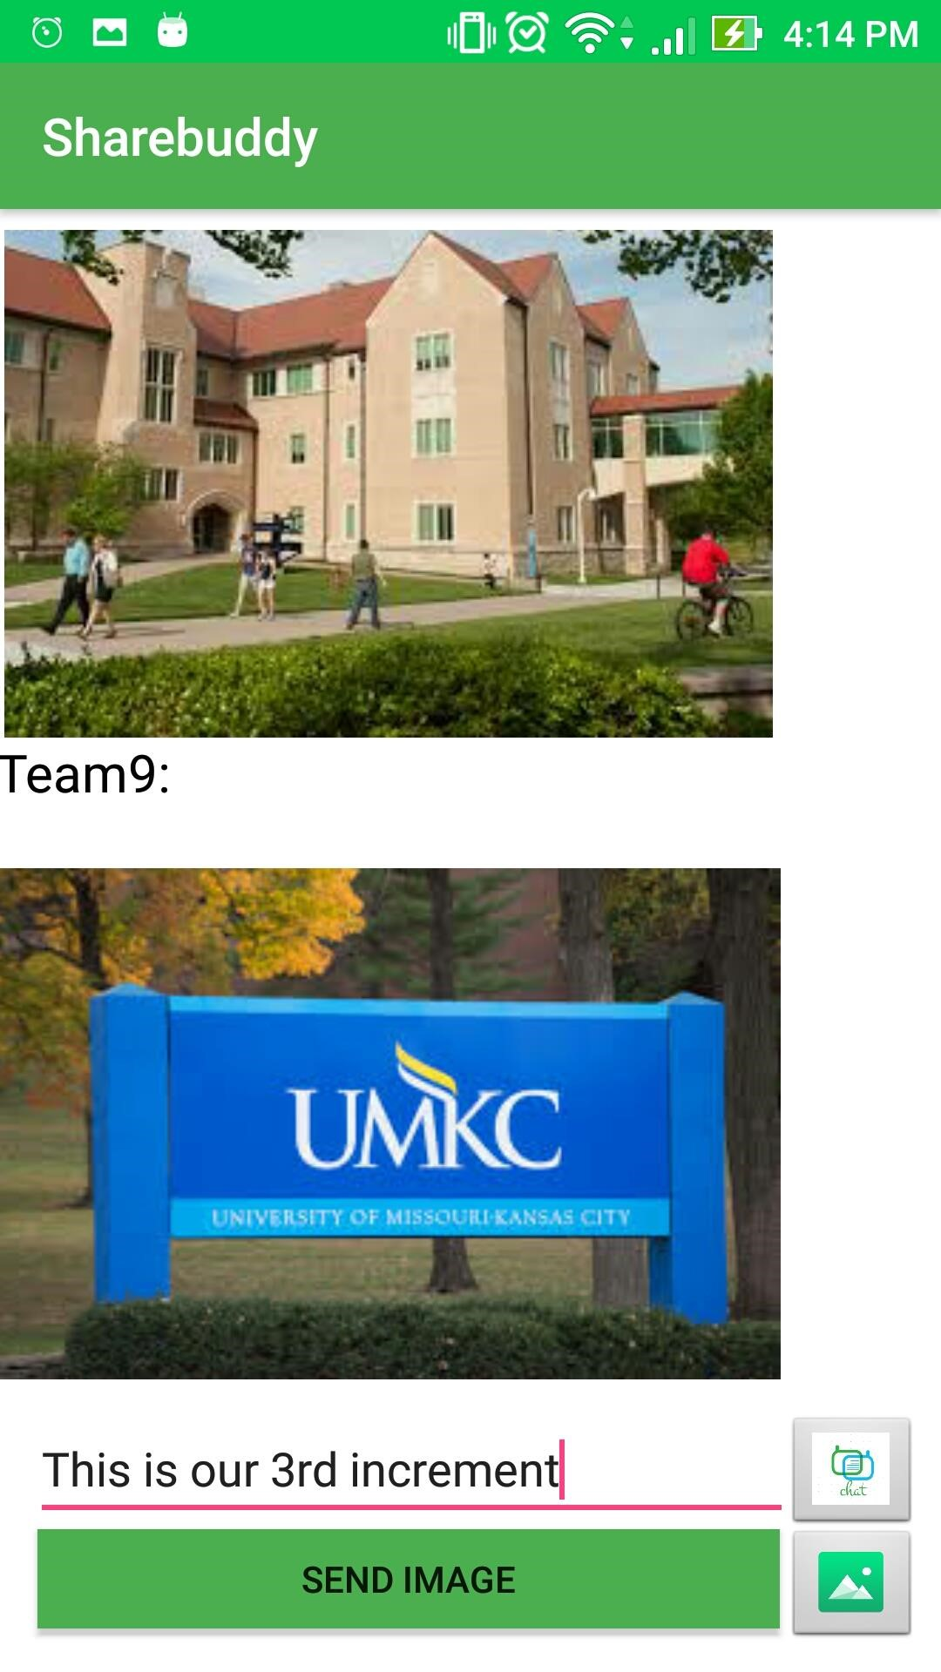

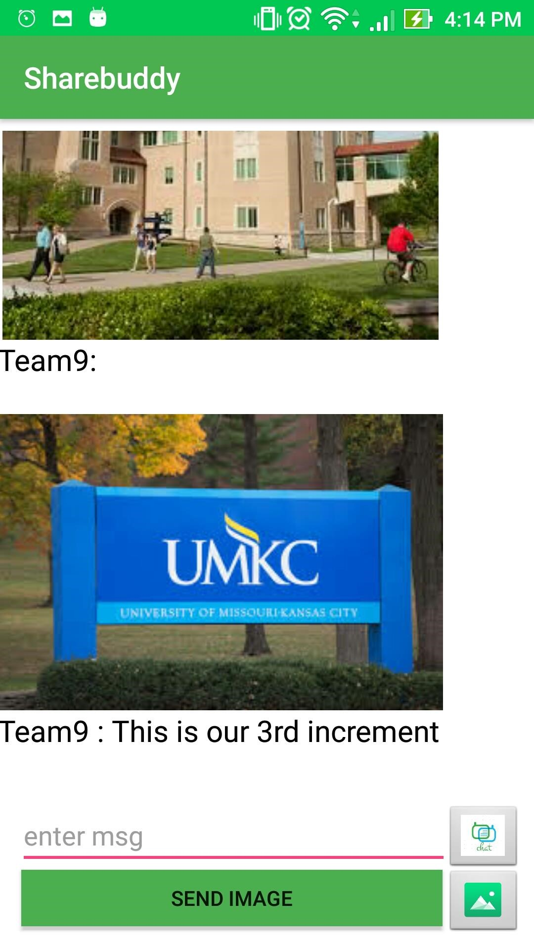

**Unit Testing:**

The below are the unit cases for second phase of the project:

|  |  |  |  |  |
| --- | --- | --- | --- | --- |
| s.no | Test case title | Description | Expected outcome | Result |
| 1 | User login verification | The user should provide valid email id and password to login. | Upon successful login, user needs to be moved to home page | Pass |
| 2 | User login validation with invalid credentials | User will enter wrong credentials | As the user have entered wrong credentials, access should be declined. | Pass |
| 3 | User login verification without details | User will not enter any credentials. | User should not be granted access as he had not entered any credentials. | Pass |
| 4. | Correct navigation to choosen page | User will give login credentials | Upon successful login, the page should navigate to course selection page | Pass |
| 5 | Navigation after choosing the course | User will select the course he is enrolled in | Upon choosing the course, user needs to be navigated to talk with tutor, ta and discussion forum page | Pass |
| 6 | Navigation to Chat Screen page | User will select the option to either talk with tutor or TA or to engage in discussion forum. | Upon Choosing the Option, User needs to be navigated to Chat Screen page. | Pass |
| 7 | Cloud database based authentication | User will be allowed only upon successful authentication match on his credentials | User will provide his sso id and password and gets logged in on successful check | pass |
| 8 | Image sharing functionality | One user will send images to other person within the app | Upon clicking gallery icon user will be redirected to gallery and choose the image he wanted to send. | Pass |
| 9 | Call function implementation | User will be able to call to the other user by using in-app calling functionality | User needs to provide friends sso and click on call icon so as to be able to call his friend | pass |

**Deployment:**

We have deployed our application on an emulator as well as on Device and have taken screenshots.

We have explained about implementation in detailed in the above sections.

**4.6. Project Management:**

**Technologies used: Android SDK, JAVA SDK,.**

**Software used: Android studio.**

**APIs used: Firebase, Sinch.**

**In this increment we have completed the following work:**

UML DIAGRAMS

Created increments in Zen Hub 3. Created wireframes using creately.

Login form modified with material design

Used spinners for drop down of courses and chat options.

Added linear layout with the material design of the screens login, courses, connect activities.

Added navigation.

Courses and Options page.

Implemented Chat Screen.

Implemented app-to-app calling functionality

Implemented app-to-app image sharing 12. Implemented authentication using fire base.

**Contributions:**

**Vamsi Krishna Challa: 33.33% (calling function implementation)**

**Shankar Pentyala: 33.3% (cloud based user authentication)**

**Girish Kumar Reddy Nagella: 33.3% (sharing pictures implementation)**

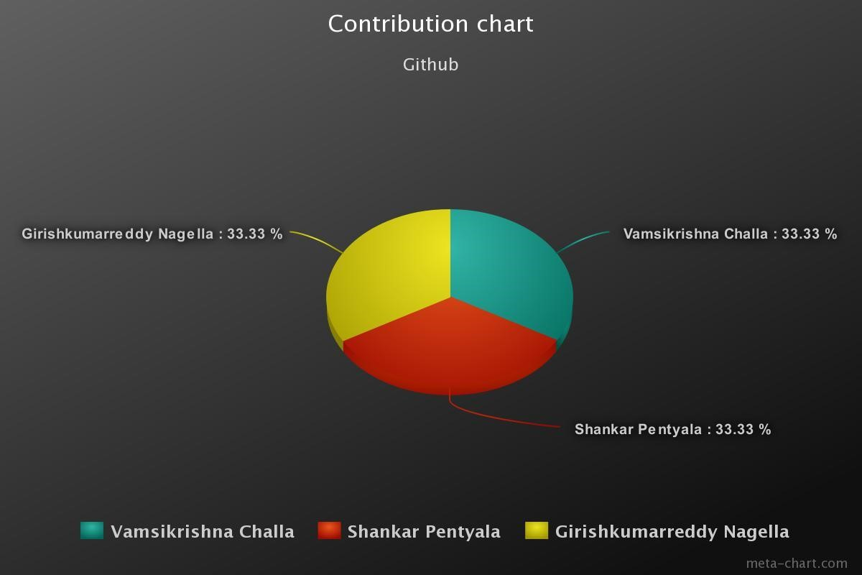

**PROJECT FINAL INCREMENT REPORT**



**CS5551 – Advance Software Engineering Project**

**Application Name: “COURSE BUDDY “**

**TEAM NUMBER: 9**

**TEAM MEMBERS:**

**VAMSI KRISHNA CHALLA**

**SHANKAR PENTYALA**

**GIRISH KUMAR REDDY NAGELLA**

**INTRODUCTION:**

**COURSE BUDDY**

Course buddy is an interactive application which acts as lifeline between students and the teaching fraternity. Student fraternity has a tendency to work along deadlines and many of the times, they tend to forget the deadlines and lose marks even having competency to complete on time. Not only deadlines, many of the student fraternity has a feeling of introvert of not being able to directly interact with the teaching fraternity.

Our COURSE BUDDY application tries to lessen the gap between teaching and student streams and also provide an interface for free flow of communication. Giving it a social media touch, would easily attract the students to make use of it.

Many times we face difficulty in finding out means to talk to our teaching faculty because of lack of availability of information. Myself, I am example how a student face difficulty in reaching faculty to break many barriers regarding the subject. As an international student, I was very much astonished at the etiquette of the college and I pulled myself backward from making a step ahead to clear my doubts regarding subjects. In the initial days, I was not able to find means of communication to reach out the faculty to be able to clarify my doubts regarding the subject and course curriculum.

So goes a saying, “Failure is the stepping stone of success.” As a blind follower of that, we tried to utilize this project opportunity to build an interface that would address the problems faced by us.

**Project Goal and Objectives:**

**Overall goal:**

Our primary goal is to develop a hybrid application “COURSE BUDDY” which is an interface between students and faculty. This interface is made using android software development kit and various other services which are needed for smooth running of applications.

**Specific objectives:**

Course buddy is used purely for educational purpose. Students login into the application to be able to talk with tutors, teaching assistants and also their course buddies without compromising their privacy

**Specific Features:**

Not compromising student’s privacy:

Many doubts of students can actually be solved by talking with their friends. But in an international institution we may not be able to easily mingle with students. Our course buddy would create a discussion forum without disclosing student’s identity and it would facilitate the student to clarify their doubts easily.

Talk with tutors and teaching assistants on a single platform:

Instead of using mail based communication to reach out to professors and using mail based or spreadsheet based communication to reach out to teaching assistants, this interface provides a unique platform to reach out both at a single click.

**Significance:**

This application in creating a healthy environment where learning evolves from different aspiring minds and would help each other to excel themselves by taking help of their professors, teaching assistants and their friends.

**Project Lifecycle:**

**Schedule for different Increments:**



**Project timelines, Members and responsibilities:**

Below are the issues that were created under each increment.

These tasks are assigned to team members.

Once the respective task is accomplished, the issue is moved to closed state.



**Burndown chart:**

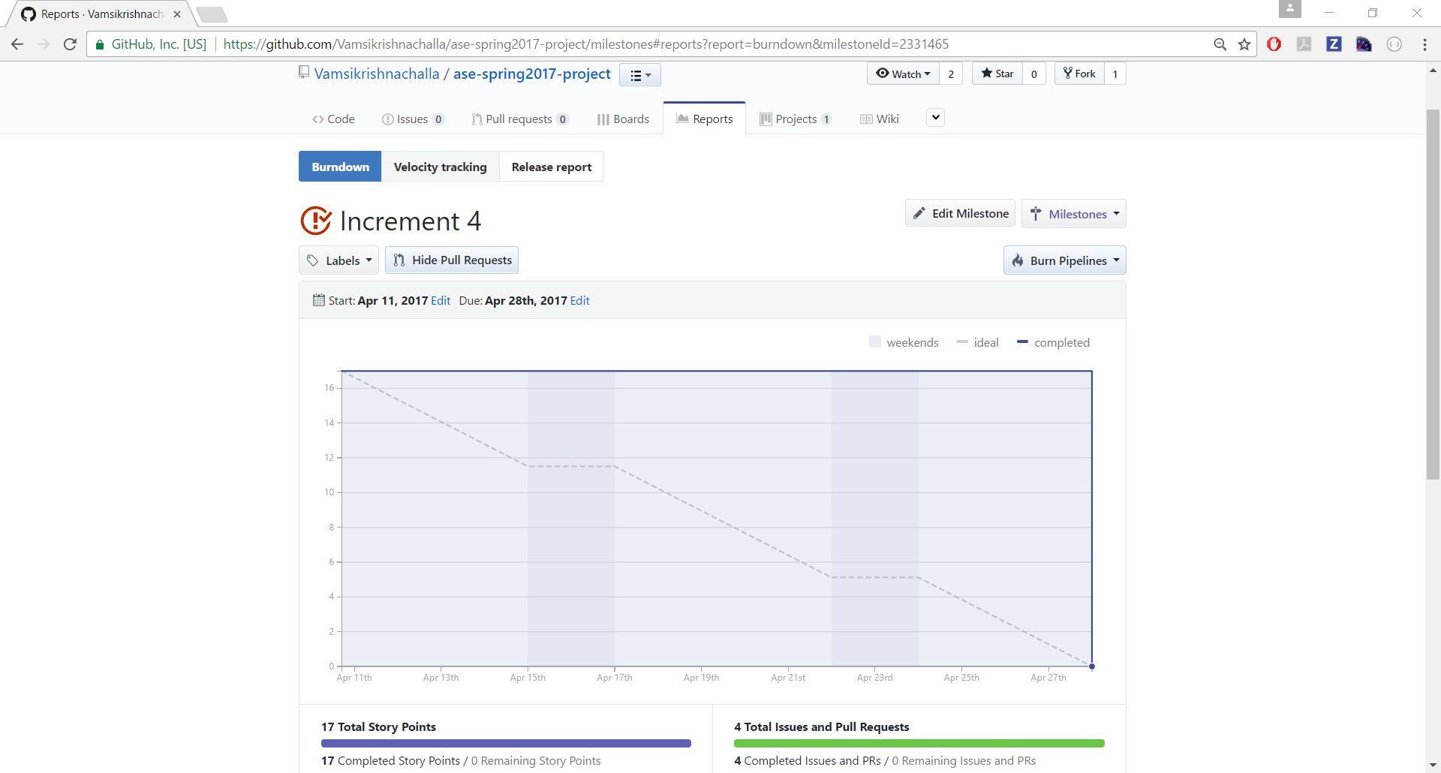

**3.4 Velocity Tracking:**



**4. Final Increment Report:**

In this Final increment, we have designed app mockups by designing wireframes and by keeping them in mind, we have designed all our app pages login page, course selection page and choosing the option to talk with anyone of the professors or teaching assistants or course buddies etc.

**4.1. Existing services / REST API:**

Throughout our project we used several services and frameworks including Firebase , Sinch , Volley and Picasso.

**4.2. Detail design of features:**

**4.2.1 Wireframes:**

**The wireframes for our project are shown below:**

**Login page: after user opens the application, one would be asked to enter the credentials to enter into the application.**



The user should have already be registered i.e., the details of the user must be already available with us as it is related to university and the details of student would be uploaded on a pre hand for authentication.

This wireframe comes once the login is successful.

In this wireframe we will be able to see the options to choose the courses In which we have enrolled.



Upon selecting the subject, we would get the option to talk with one of the required persons which we are needed to talk to like:

Professor

Teaching assistants

Course buddies.

This is the wireframe for choosing the option to talk or else log off from the application.



Upon Selecting an option, you will be redirected to chat screen,



**4.2.2 User Stories:**

**Class diagram:**



**Software architecture diagram:**



**Sequence diagram:**



**Design Patterns Used:**

Observer Pattern: In our code,

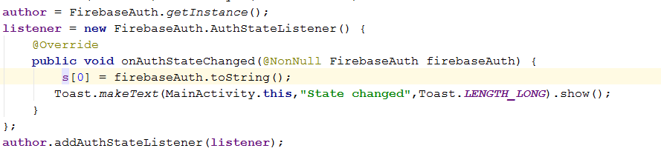

State Pattern : In our code,

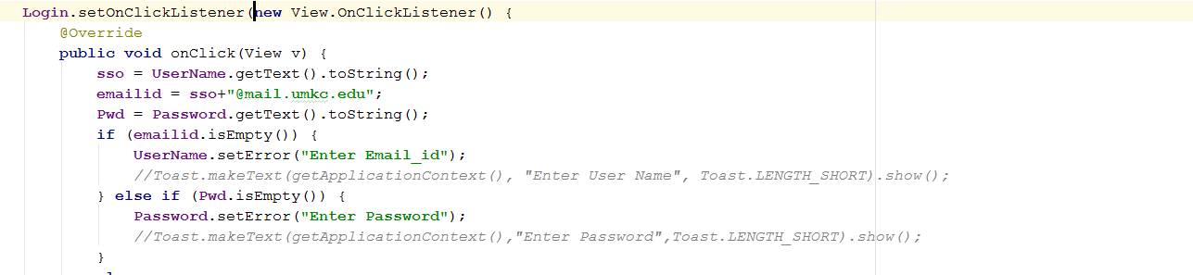

**4.3. Implementation:**

**Home page for application:**



**On successful login, we would get the option to choose the course:**





**On selecting the course, we would get an option to talk with anyone: **



**On selecting the option Discussion Forum, A chat Screen opens.**



**On selecting the option Talk with TA, another screen opens**



**On selecting the option Talk with professor, professor screen opens**



**Also, we can perform App-App Image Sharing:**



**Finally, App-App calling is possible,**

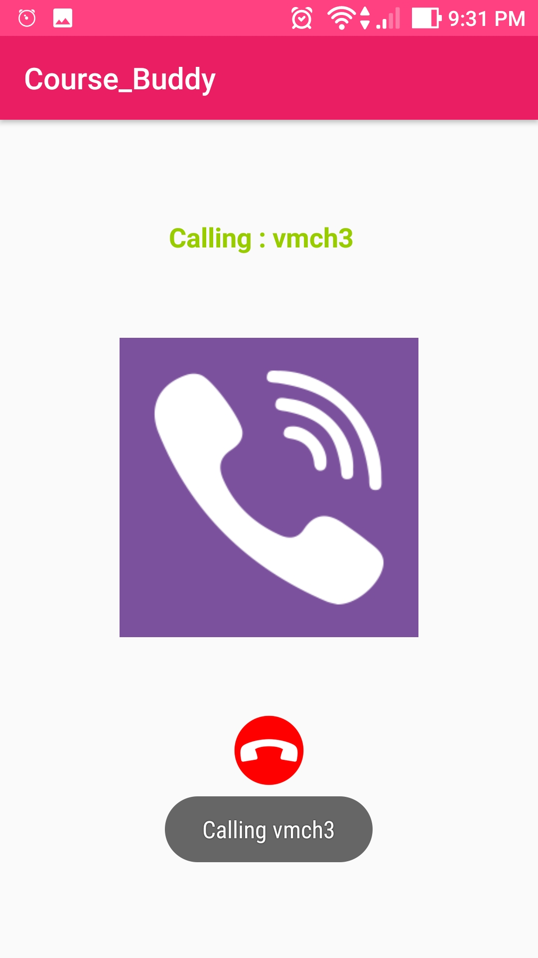

**If we login as Tutor/TA:**



**Tutor/TA can send Important updates to students**,



**4.4. Unit Testing:**

The below are the unit cases for final phase of the project:

|  |  |  |  |  |
| --- | --- | --- | --- | --- |
| s.no | Test case title | Description | Expected outcome | Result |
|  |  |  |  |  |
| 1 | User login verification | The user should provide valid email id and password to login. | Upon successful login, user needs to be moved to home page | Pass |
| 2 | User login validation with invalid credentials | User will enter wrong credentials | As the user have entered wrong credentials, access should be declined. | Pass |
| 3 | User login verification without details | User will not enter any credentials. | User should not be granted access as he had not entered any credentials. | Pass |
| 4. | Correct navigation to choosen page | User will give login credentials | Upon successful login, the page should navigate to course selection page | Pass |
| 5 | Navigation after choosing the course | User will select the course he is enrolled in | Upon choosing the course, user needs to be navigated to talk with tutor, ta and discussion forum page | Pass |
| 6 | Navigation to Chat Screen page | User will select the option to engage in discussion forum. | Upon Choosing the Option, User needs to be navigated to Chat Screen page. | Pass |
| 7 | Navigation to Call Screen page | User will choose to call by clicking the call icon on top. | Upon Choosing to call, User needs to be navigated to Call Screen page | Pass |
| 8 | Navigation to Talk with Professor and Talk with TA pages. | User will select the option to either talk with tutor or TA. | Upon Choosing the Option, User needs to be navigated to respective pages. | Pass |

**4.5. Deployment:**

We have deployed our application on an emulator as well as on Device and have taken screenshots.

We have explained about implementation in detailed in the above sections.

GitHub link for source code and documentation:

**4.6. Project Management:**

**Technologies used: Android SDK, JAVA SDK.**

**Software used: Android studio.**

**Services used: Firebase and Sinch.**

**By this increment we have completed all the work:**

UML DIAGRAMS

Created increments in Zen Hub

Created wireframes using creately.

Login form modified with material design

Used spinners for drop down of courses and chat options.

Added linear layout with the material design of the screens login, courses, connect activities.

Added navigation.

Courses and Options page.

Implemented App-App Chatting.

Implemented App-App Image Sharing.

Implemented App-App Calling.

Implemented Secure authentication.

Implemented Notifications for important updates.

Different screens for different users.

**Contributions:**

**Vamsi Krishna Challa: 33.33%**

**Shankar Pentyala: 33.3%**

**Girish Kumar Reddy Nagella: 33.3%**



**Links:**

**Final Presentation:** <https://github.com/Vamsikrishnachalla/ase-spring2017-project/blob/master/Course%20Buddy.pptx>

**GitHub:** <https://github.com/Vamsikrishnachalla/ase-spring2017-project>

**You Tube:** <https://www.youtube.com/watch?v=9lWSdZeLENQ>